Appendix A – UWEMS Proposal Draft
The following pilot proposal is the foundation of the UWEMS program.
This document was developed by
Tristan Jafari (B.S. Biochemistry, UW, 2025), Patrick Bi (MD, UW School of Medicine, 2026) and Tanmay Bhanushali (B.A. Linguistics, UW, 2026).
Note: Elements of the proposal may be outdated and do not
necessarily reflect the current operations of UWEMS.

University of Washington
Emergency Medical Services

Pilot Program Proposal

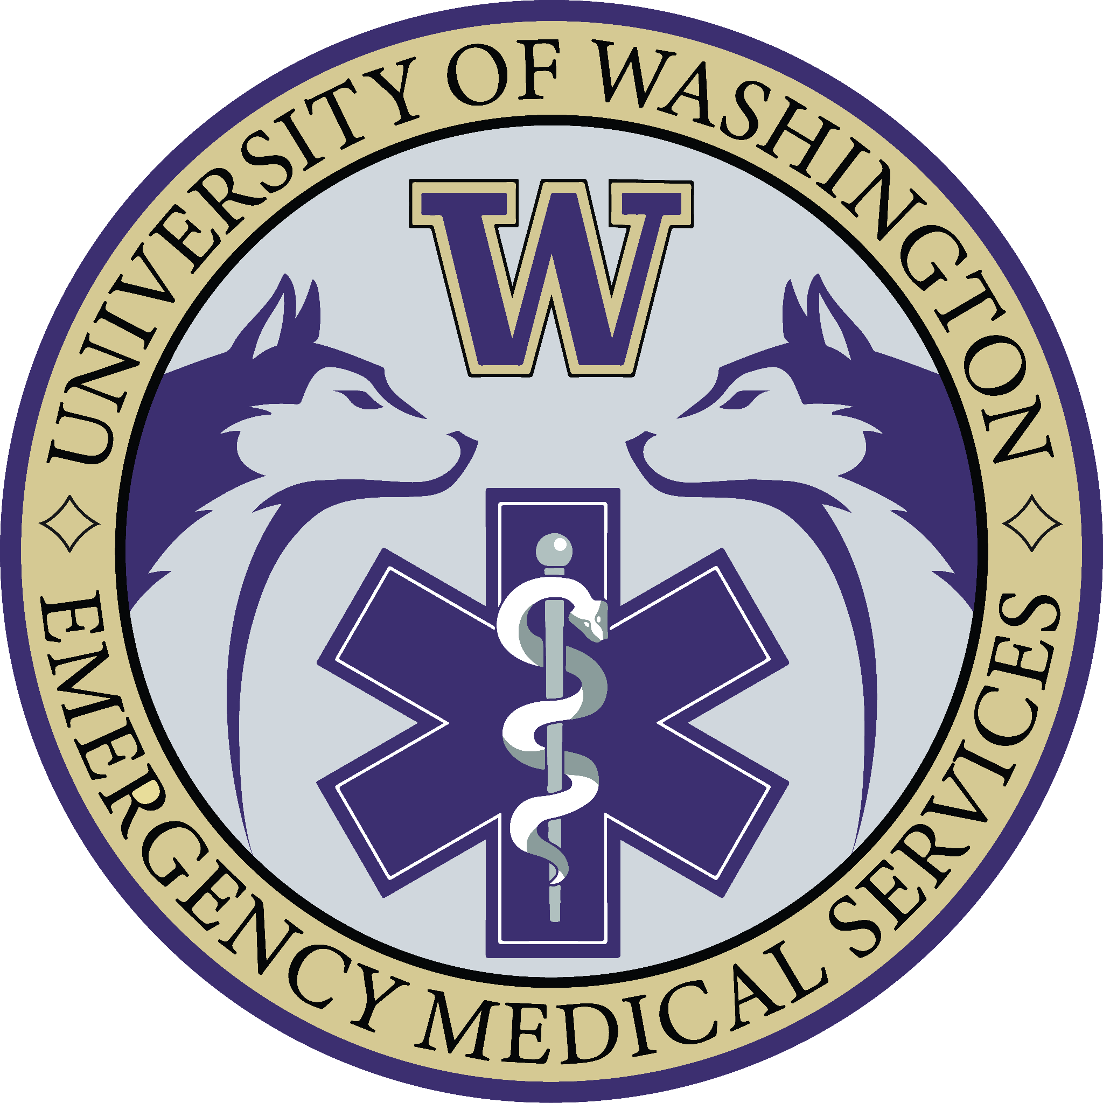
Submitted: 05/01/2024
Recipient: UW Medicine

Written by:
Tristan Jafari, EMT
Tanmay Bhanushali, EMT
Patrick Bi, EMT

Written on behalf of the 190 students of the
UWEMS Initiative

Table of Contents

About UWEMS  History of the Proposal  Purpose of the Proposal  Mission Statement  Vision Statement | 1
Overview of Current Response Model | 2
Scope of Practice  Level of Care  Response Logistics  Authority Having Jurisdiction | 4
Analysis of Potential Benefits  Medical Benefits  Community Benefits  Educational Benefits | 7
Governance Plan  University Integration  Organizational Chart  Medical & Operational Oversight  Administrative & Training Oversight  Student Leadership Structure | 13
Pilot Program Overview  Timeline  Stage 1  Stage 2  Stage 3 | 19
Student Interest & Personnel Requirements  Student Interest  Personnel Requirements | 26
Onboarding and Training  Ongoing Training and Evaluation Program (OTEP)  Mental Health Training  Field Training and Preparation  Infractions and Disciplinary Actions | 28
Dispatch & Documentation  PulsePoint Professional Respond Dispatch  ESO Software | 37
Legal, Liability & Insurance  EMT Licensure  Agency Licensure  Medical Liability  UW Compliance and Risk Services  Volunteer Firemen’s Insurance Services | 40
Budget Proposal  Timeline  Itemized Budget | 44
Quality Assurance and Quality Improvement  Public Training & Community Outreach  Call Review  Clinical Data  Community Feedback  Annual Report | 46
Beyond the Pilot Program  Full Operations  Research | 50
Special Thanks & Acknowledgments | 53

About UWEMS

The University of Washington Emergency Medical Services is a collegiate EMS agency composed of UW students who are state-certified Emergency Medical Technicians (EMTs). The agency aims to receive medical direction through the Department of Emergency Medicine and aims to operate within the UW Paramedic Training Program. The agency will function as a non-transport, basic life support, quick-response service, supplementing the Seattle Fire Department. UWEMS EMTs shall respond to medical 9-1-1 calls within the geographic boundaries of the University of Washington Main Campus and Health Sciences Campus.

History of the Proposal

The idea of establishing a collegiate EMS agency at the University of Washington was conceived in Spring 2023. Collegiate EMS agencies exist at over 250 colleges and universities across the nation, growing at a rate of 4.3 new established agencies a year. Students began by interviewing dozens of established collegiate EMS agencies, conducting a thorough literature review, and organizing preliminary meetings to assess the potential viability and benefits of UWEMS. In culmination of that research period, the following proposal was drafted. UWEMS would mark the inception of the first collegiate EMS agency in the State of Washington.

Purpose of the Proposal

This proposal serves as an outline to establish a Pilot Program for a student-run emergency medical service at the University of Washington. The Pilot Program will run from January 6rd, 2025 through June 6th, 2025 and will only operate during the academic year. The proposal presents data and information gathered from key stakeholders with the goal of successfully implementing UWEMS at the University of Washington.

Mission Statement
The mission of UWEMS is to improve the health and well-being of the University of Washington community by providing high-quality emergency response, standby, and training services.

Vision Statement
We envision a campus environment where members of the UW community are empowered and supported in their most vulnerable moments.

Overview of Current Response Model

Response for urgent medical attention at the University of Washington is managed through a variety of resources and services including:

Urgent Medical Services Currently Offered on Campus
Service | Description
UW Medicine Hall Health Center | Primary and Urgent Care available during business hours
Seattle Fire Department | Basic and Advanced Life Support through 9-1-1 dispatch
American Medical Response | Basic Life Support transport by SFD request
UW Medicine Neighborhood Ravenna Clinic | Primary and Urgent Care available during business hours
After Hours Community Care Line | Nurse advice by phone available 24/7
UW Mental Health (HuskyHelp) Line | Confidential phone or text conversation with counselor available 24/7
UW Counseling Center | Urgent care meetings for during crisis

In the case of on-campus medical emergencies in which rapid stabilization or transport to an urgent care center or emergency room (ER) is clearly indicated, individuals (either bystanders or the patients themselves) are directed to call 9-1-1 immediately to initiate the emergency response chain. Otherwise, individuals seeking medical attention for non-emergent events are encouraged to access alternative resources, outlined above.

In emergent 9-1-1 situations, Seattle Fire Department (SFD) emergency responders arrive on-scene to perform an initial scene size up alongside stabilization and assessment of the patient’s condition. Based on the assessment, BLS/ALS interventions can be immediately initiated. If transport is deemed necessary, the patient is transported to the appropriate care facility by American Medical Response (BLS) or Medic One (ALS).

Flowchart of Current Emergency Medical Response System
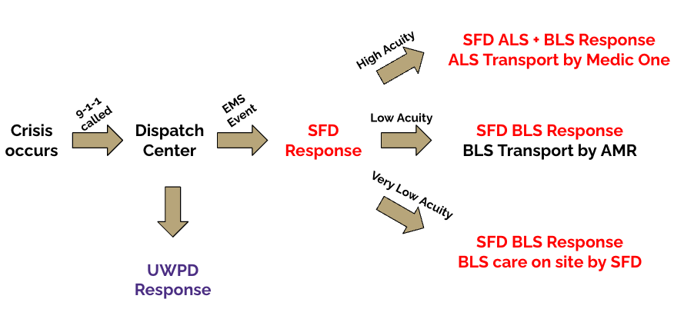
*High acuity calls involve acute life-threatening conditions (i.e. cardiac arrest). Low acuity calls involve non-life-threatening conditions that require hospital care (i.e distal radius fracture). Very low acuity calls involve non-life-threatening conditions that do not require hospital care (i.e. minor laceration).

Scope of Practice

Level of Care
All UWEMS providers are required to be nationally registered EMTs. EMTs are medical professionals that must graduate an intensive 3-month period of training from an accredited program by successfully completing written and practical examinations, including the standardized NREMT exam.
Under the supervision of a licensed physician, EMTs are authorized in the State of Washington by the Department of Health to provide emergency medical services to the sick and injured as outlined in the RCW 18.73.030 and RCW 18.71.205. The medical scope of practice for EMTs in King County is described in the Seattle and King County Patient Care Guidelines, authored by Dr. Michael Sayre and Dr. Thomas Rea.
As UWEMS is staffed by EMTs, the agency will provide care in accordance with the above, exclusively within the defined scope of practice at the Basic Life Support (BLS) level.

Response Logistics
From conversations with peer institutions with collegiate EMS models and campus/regional stakeholders, the most appropriate response scope for UWEMS is as a Quick Response Service (QRS). The following are key points about the function and purpose of QRS agencies:

- QRS agencies respond rapidly to provide initial care to patients prior to the arrival of other agencies
- QRS agencies do not transport patients
- QRS agencies do not change how existing agencies respond to calls
- QRS agencies do not change expectations for public use of the 9-1-1 system
- QRS agencies operate at the BLS level
In other words, enabled by rapid response times, UWEMS will provide professional medical care to sick and injured patients during minutes in which they otherwise would not have not received treatment. On-scene leadership and patient care on the UW campus will continue to be within the scope and authority of the Seattle Fire Department. UWEMS would provide initial BLS care and facilitate a transfer of patient care as soon as SFD personnel arrive on scene.
Should SFD arrive on scene first instead, UWEMS would serve as supplementary BLS support if requested by SFD personnel. UWEMS will use PulsePoint Professional Respond to be dispatched alongside SFD. See Dispatch & Documentation | PulsePoint Dispatch for more information.

The following table is an example of a BLS to ALS upgrade call with SFD Engine 17 and Medic 17 responding under the current EMS system.

Current Campus Emergency Response System*
Time (min.sec) | Entity | Description
0.00 | Patient/Bystander | Medical emergency occurs and 9-1-1 is called
1.00 | SFD & UWPD | Units receive assignments and dispatch
6.38 | SFD E17 | Arrival to provide BLS and scene leadership
7.47 | UWPD | Arrival to secure scene
8.00 | SFD E17 | ALS upgrade decision made (if needed)
14.00 | SFD M17 | Medic arrival to provide ALS (if needed)
* Assuming 1 minute and 22 seconds are needed to upgrade to ALS and a 6 minute ALS response time.

This following table is a representation of how UWEMS could supplement a call similar to the prior example. In this example, BLS response time is decreased by 60% and ALS response time is decreased by 35%.

Proposed Campus Emergency Response System*
Time (min) | Entity | Description
0.00 | Patient/Bystander | Medical emergency occurs and 9-1-1 is called
0.20 | UWEMS | PulsePoint dispatch notification received
1.00 | SFD & UWPD | Units receive assignments and dispatch
2.56 | UWEMS | Arrival to provide BLS
3.20 | UWEMS | ALS upgrade decision made (if needed)
6.38 | SFD E17 | Arrival to provide BLS and scene leadership
7.47 | UWPD | Arrival to secure scene
9.20 | SFD M17 | Medic arrival to provide ALS (if needed)
* Assuming 1 minute and 24 seconds are needed to upgrade to ALS and a 6 minute ALS response time. Green highlights indicate events that are added or occur earlier than the current model.

Flowchart of Proposed Emergency Medical Response System
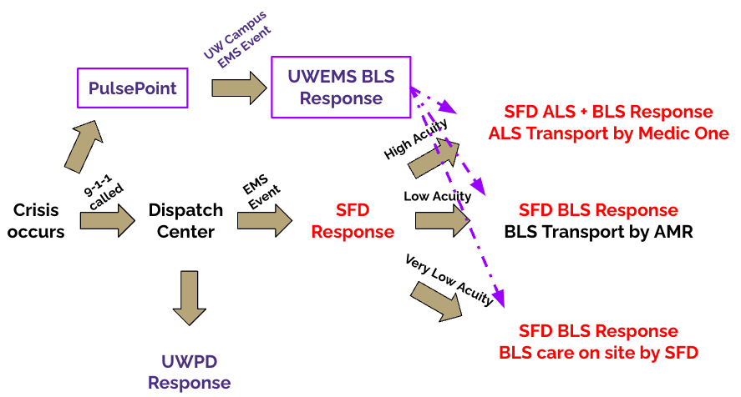
*High acuity calls involve acute life-threatening conditions (i.e. cardiac arrest). Low acuity calls involve non-life-threatening conditions that require hospital care (i.e distal radius fracture). Very low acuity calls involve non-life-threatening conditions that do not require hospital care (i.e. minor laceration).

Authority Having Jurisdiction
In perpetuity, UWEMS will never be or seek to be the authority having jurisdiction (AHJ) for the emergency medical response on UW campus. That authority is unequivocally reserved for the Seattle Fire Department. UWEMS shall not, in any capacity, negatively impact the wages, hours, or working conditions of the Seattle Fire Department. UWEMS will work solely to serve as a community partner to the Seattle Fire Department in order to enhance the existing emergency response model, and benefit the community on the UW campus.

Analysis of Potential Benefits

In examining the need for UWEMS, it is important to consider the medical, educational and community benefits to the University of Washington. All three of these considerations are significant, especially to ensure that the implementation of UWEMS is consistent with the mission, vision and values of the University of Washington in providing students a safe community and an environment to pursue a wide range of educational opportunities.

Medical Benefits
- Improved Response to Mental Health Crises
The Healthy Minds Study, in which the University of Washington participates, reveals extensive mental health concerns that exist for many college students. In conversations with SFD and many members of UW Administration, it is clear that many emergency response calls that occur on campus relate to acute mental health crises.

Broadly, it is considered essential that campus emergency medical response be specialized in providing effective mental health aid. In this regard, collegiate-based emergency medical services (CBEMS) agencies offer distinct advantages when responding to on-campus mental health crises (e.g. panic attacks, severe depressive or manic episodes, self-harm, and suicidal ideation/attempts) that may require immediate intervention.

As college students at a similar life stage, CBEMS providers have the unique advantage of being peers to the patients they care for, being much more likely to identify with many of the same stressors and triggers experienced by the patient when compared to a typical EMS provider (Friedman et al., 2022). The ability to create trusting patient-provider connections on a common ground has been linked to better healthcare delivery and outcomes, and this idea has already been implemented across the world with great success (Mental Health America). Especially on college campuses, peer support has been shown to have a transformative effect on both individuals and systems, especially following the COVID-19 pandemic (MassInc Polling Group).

Ultimately, CBEMS EMTs are fully licensed as medical providers and are trained to perform initial evaluations of psychiatric emergencies, make safe connections with patients, and arrange for transport to appropriate facilities for a higher level of care (Friedman et al., 2022). Since UWEMS is focused on serving the campus-specific patient demographic, supplemental EMT training will be tailored to emphasize the most common medical needs on a University campus, better preparing responders. See Onboarding & Training | Mental Health Training for more information. Additional training is a common practice for EMTs who work in more specialized areas, such as in correctional facilities or industrial settings. EMTs who are well-situated to respond to mental health crises are crucial for delivering high-quality care to the students at the University of Washington, and can improve responses to one of the most relevant emergencies that occur on campus.

- Increased and Safer Reporting of Emergencies
Another medical benefit that UWEMS can bring to the UW community is the demonstrated impact a collegiate-based EMS program has on promoting a culture of campus safety. In a retrospective study conducted on a college campus before and after its implementation of a CBEMS program, it was found that the introduction of CBEMS to campus increased student reporting of alcohol-related emergencies by over 100% (Rosen et al., 2012). This change was attributed to students feeling increasingly comfortable in sharing and reporting emergencies when they were aware the first responders would be peers, and not from outside agencies.

The ultimate effect of CBEMS implementation was the growth of a safer reporting culture on-campus, and a reduced number of acute alcohol-related injuries as a result of hesitating to seek evaluation when it was medically necessary. This evidence is further supported in universities which have a combination of both a medical amnesty policy (MAP) and a CBEMS agency - similar to the medical amnesty policy implemented in Washington State. In a study at one such urban university, it was observed that the combination of MAP and CBEMS resulted in a 60% decrease in alcohol-related calls requiring ALS level care or transport (Monahan et al., 2018). It was suggested that this decrease was due to the fact that students were empowered and able to call for medical assistance before patients became acutely ill.

These results reflect how students perceive the EMS system in colleges with CBEMS agencies, and complements UW’s ongoing efforts to divert students away from fear of consequence and towards seeking help. Additionally, we believe that the increased reporting behaviors seen in the alcohol-related emergencies study can be reasonably extended to other sensitive emergencies that students may be hesitant to request assistance for, including drug overdoses, mental health crises, and sexual assault.

- More Rapid Response to Campus Emergencies
One of the core goals of UWEMS is to complement and support the existing emergency response model provided by SFD at the University of Washington. To this end, the implementation of UWEMS will further help decrease the time between medical emergencies and when patients begin to receive pre-hospital care. We have collected retrospective response data from the Seattle Fire Department’s call history logged on SFD LIVE during the 2022-2023 academic year for emergencies on UW’s main campus requiring Basic Life Support (BLS) level care. Because we were primarily interested in gathering response data from incidents on UW campus, call data originating from University Way was excluded.

From our data collection, we determined SFD’s mean BLS response time for calls originating on UW campus to be 6.4 (SD = 2.1) minutes, which are strong statistics when compared to the national average of 7 minutes for urban EMS agencies (Mell et al., 2017). However, it also reveals a possibility for improvement. While the SFD response times to UW campus emergencies are notably faster than the national average, 11% (n=52/472) of the BLS level calls on UW campus had response times of 7 minutes or greater, 50% of which (n=23/472) had response times of 9 minutes or more.

Historically, the impact of faster response times on morbidity and mortality is well-documented, but the major limiting challenge for EMS agencies in urban settings is logistical feasibility. As an example, the recommendation for EMS agencies to initiate CPR within 4 minutes of a cardiac arrest event to avoid brain damage, is still being advocated for to achieve higher survival rates (Blackwell & Kaufman, 2001). Even if patient outcomes for a majority of life-threatening calls would improve with a 4-minute standard, the extraordinary costs required to staff and meet this objective makes it infeasible on a large scale (Blackwell & Kaufman, 2001). As demonstrated, the Seattle Fire Department is one of the most successful agencies in the nation when it comes to providing efficient, quality care to patients. However, SFD’s average response time to emergencies on UW campus can still be improved to meet the 4-minute benchmark. With the advantages that a CBEMS agency provides, UWEMS is uniquely positioned to help SFD deliver care and improve patient outcomes without creating exorbitant costs or additional logistical hurdles.

From data collected by the National Collegiate Emergency Medical Services Foundation (NCEMSF), the average response time for CBEMS agencies is 2.6 minutes (Mell et al., 2017). Having a team of on-campus EMTs who can arrive before SFD will benefit both the patient and SFD responders. UWEMS can initiate early care and stabilization, in addition to gathering pertinent health information to better facilitate the transfer of care once SFD providers arrive. In cases where CPR is required, UWEMS EMTs can begin within the ideal time frame of 4 minutes, resulting in a potentially life-saving intervention.

Though we recognize that shorter response times are not the sole predictor of improved patient outcomes in emergencies, it is widely accepted that early stabilization, patient history gathering, and triage is undeniably valuable in acute settings (Wilson et al., 2015). Therefore, any opportunity to initiate patient care sooner during medical emergencies with minimal modification to the current response model should be strongly considered to benefit the students, faculty and staff of the University of Washington.

- Faster ALS Upgrade and Support in Life-Threatening Situations
As part of a faster emergency response, UWEMS will also be beneficial to the current emergency response model in cases when a call needs to be upgraded from BLS to ALS level care. In these cases, early response is critical as it will allow UWEMS to request SFD ALS support sooner, and increase the ability of SFD to provide early and effective transport of critically ill patients.

In the last academic year, there were 15 (n=15/469, 3.2%) incidents where such an upgrade was indicated. In these cases, the mean BLS response time was 6.1 (SD = 2.5) minutes. For patients who require ALS level care, urgent stabilization and transport to an emergency facility are of the utmost priority. However, as demonstrated by these cases, in the current model patients have to wait for an average of at least 6 minutes before the need for ALS upgrade can be recognized by a BLS provider. The patient will then also need to wait the additional time for transport to arrive on-scene. With a CBEMS, in which responders are able to arrive on-scene faster, there is an opportunity to upgrade a call to ALS sooner, thus reducing delays in care.

In addition to these cases, there were 56 (n=56/469, 11.9%) incidents requiring BLS level support alongside ALS level care. In these instances, the average BLS response time to the scene was 5.9 (SD = 2.7) minutes. We believe these cases also provide an opportunity for UWEMS EMTs to give additional scene support for SFD, and improve efficient healthcare delivery and transport in critical or life-threatening scenarios.

Community Benefits
- Emergency Preparedness and Health Education
The purpose and intention of UWEMS will always be to serve the University of Washington community. Because of this, a large part of UWEMS’s efforts will be directed towards community outreach. This will mainly take the form of teaching CPR/AED classes and Naloxone/opioid overdose education. All classes will be available to the students, faculty and staff on a regular basis, and will be taught by members of UWEMS who have been trained as certified instructors.

In addition to teaching classes, UWEMS will also plan to host regular campus events such as Stop the Bleed to teach the community about emergency wound care and management. UWEMS will also be able to help provide free vitals screening such as blood pressure, heart rate, and blood glucose monitoring at regularly-scheduled campus events. Through community outreach and events, UWEMS hopes to promote health literacy and access to care. UWEMS will also work closely with UW administration and campus clinics such as Hall Health to plan and coordinate any other health events to benefit UW and its surrounding community.

Furthermore, by involving students in the emergency response system on campus, it may spark a wider student interest in pursuing further emergency preparedness training. Thus, beyond the lifesaving nature of these skills, participation in these systems may encourage students to become further involved in the health and well-being of their community.

- Expansion of Medical Standby at University Events
UWEMS will seek to provide medical support for SFD and AMR standby at sporting events, campus events, and/or commencement. Additionally, UWEMS will work with SFD and UW administration to identify and help provide standby support for any other events that may benefit from additional medical services. Providing standby support at these events will help allow for better coverage of attendees, and increase the resources available to provide care for medical emergencies at any campus event. See Pilot Program Overview - Stage 3 for further details regarding event standby.

- Improved University Image
The University of Washington at its core is an exemplary learning environment and research powerhouse - but it is also a cultural institution and a pillar of the Seattle community. Though these values might not translate directly to a financial benefit, they serve as a large reason why prospective students and their families choose year after year to join the UW community. We believe that there are few better ways to demonstrate a commitment to student health, well-being, and development than encouraging professionally-qualified and campus-based responders to take care of students, staff, faculty, and other community members when they are implicated in medical emergencies.
A CBEMS agency is a historically major selling point for a university, and could become the deciding factor when a prospective student and their family is choosing between two otherwise similar institutions. Because of this, universities frequently display and advertise the benefits their CBEMS agency brings to the community at campus tours, sporting events, and on social media. Perhaps most importantly, the agencies are celebrated and broadcasted in the news, for instance, here.
UWEMS is an opportunity for the University of Washington to reinforce its strong reputation and earn acclaim as an institution that actively invests in the welfare of its constituents and is committed to take whatever action necessary for improving the care provided for both mental and physical emergencies experienced by students, staff, and faculty.

Educational Benefits
- Career Development Opportunities for UW Students
UWEMS hopes to provide students with career-exploration opportunities that they may not otherwise be exposed to in a typical university setting. For many, working within UWEMS will be their first exposure to the EMS system. As UWEMS will work closely with SFD and private ambulance companies, students have a unique opportunity to cultivate strong relations with firefighters, EMTs, and paramedics, all who may provide valuable perspectives and career advice. Engagement with these entities may further encourage students to pursue career paths that they might not otherwise have had much exposure to, and also a chance to interface careers in with both pre-hospital settings and emergency medicine.

- Clinical Experience and Hands-On Leadership
UWEMS is committed to enhancing the education and development of the students and volunteers who will make up its leadership and crew. UWEMS is intentionally student-driven, recognizing the value of peer-to-peer interaction and how medical care is often best delivered by those who can relate and connect to patient experiences.

UWEMS will also provide unique learning and leadership opportunities for students interested in pursuing their healthcare interests through community service. UWEMS offers students the opportunity to be directly responsible for patient care. Furthermore, a volunteer EMS squad would provide students with leadership and teamwork opportunities, as well as enhance critical decision making and management skills. Participation in such an agency demonstrates a commitment to service, leadership, and practical experience that is highly valued by employers and graduate schools alike. Graduates who have been part of this agency will stand out in the competitive job market and graduate school admissions processes.

- Research Opportunities in Emergency Medicine
As a program, UWEMS will fully support any students who wish to pursue investigation into research hypotheses or inquiries they have regarding pre-hospital care in a university setting. Though CBEMS and EMS services share similarities, there are still significant differences between CBEMS organizations and traditional EMS agencies. In particular, CBEMS agencies are typically uniquely located within college premises, which are often characterized by complex physical layouts, frequent mass gatherings, and population-dense areas (Friedman et al., 2018). In addition, the population that CBEMS agencies serve and care for are often unique as well, typically with similar age demographics, and distinct clinical, social and psychological needs. Given this incredibly unique environment, exploring research and scholarship in the field of CBEMS is an exciting opportunity for the CBEMS community at large (Friedman et al., 2018). Promoting such research will not only provide students with opportunities to initiate their own rigorous clinical and medical investigation, but also engage them with a growing field of CBEMS research that is already occurring at other universities across the country.

Governance Plan

University Integration
A look over 200 collegiate-based EMS organizations shows that agencies are frequently administratively integrated within an existing university structure. University integration is essential for liability, insurance, and financial considerations to be appropriately addressed before the approval of the Pilot Program.
Collegiate EMS Oversight
Group | Campus Population | Oversight
University of North Carolina EMS | 31,705 | Campus Health Services
University of California - Riverside EMS | 26,809 | Campus Police Department
University of Pennsylvania EMS | 28,201 | Division of Public Safety
University of California - Los Angeles EMS | 44,947 | Campus Police Department
Utah Valley University EMS | 43,099 | Emergency Management and Safety
University of Arizona EMS | 51,134 | Campus Health Services
UWEMS aims to be administratively integrated within the UW Paramedic Training Program (UW PMT), a unit that resides within the School of Medicine’s Department of Emergency Medicine.
UW PMT is an Emergency Services Supervisory Organization (ESSO) under the WA Department of Health as defined by RCW 18.73.030. ESSOs are authorized to use EMS personnel to provide medical care as defined by RCW 18.73.130. This qualifies UW PMT to effectively manage and provide an oversight structure for UWEMS.
For the duration of the Pilot Program, a director of UW PMT shall serve as the Executive Director of UWEMS. The Executive Director will serve as the primary touchpoint for UWEMS to the UW Administration, ensuring that UWEMS follows all legal requirements and University guidelines. Additionally, the Executive Director will facilitate interdepartmental relations and give logistic guidance to the Board of Directors (BOD). If the Pilot Program is renewed, UWEMS will coordinate with UW PMT to develop a long-term plan for oversight. The role of Executive Director should be graduated into a formalized and long-term administrative oversight position.

Organizational Chart

3
Logistics
Chief
Finance
Operations
Quality Assurance
Field Training
Onboarding
EMT Personnel
Admin

Medical Director
Seattle Fire Department
Medical & Operational
Executive Director
Administrative & Training
Training Director
Outreach
Non-Student Oversight
Equipment
Public Relations
ARC CPR Instructors
Naloxone Instructors

Board of Directors

Officer(s)

Other

Stakeholders
Advisors
Deputy Chief

Medical & Operational Oversight
UWEMS MEDICAL DIRECTOR
As a board-certified physician, the UWEMS Medical Director will play a central role in overseeing all medical operations of the agency. They will have full discretion over the Standard Operating Procedures (SOPs) and medical scope of the organization. The Medical Director will establish and review medical protocols to ensure that UWEMS delivers high-quality and evidence-based care, tailored to the unique demographic of a university campus. In cases of major medical incidents, the Medical Director will lead the review and analysis of the response, identifying lessons learned and opportunities for improvement.

Additionally, the UWEMS Medical Director will participate in quarterly call reviews with the UWEMS Board of Directors. In these reviews, the Medical Director and the BOD will review notable patient care reports from the current quarter to assess. These notable patient care reports will have been those which have been flagged by the Clinical Care Committee (see Quality Assurance and Quality Improvement | Call Review). Special attention will be given to the type of call, the quality of documentation, the quality of care provided, and areas of strengths and weaknesses in the SOPs.

For the duration of the Pilot Program, an interim Medical Director should be found with support from the Department of Emergency Medicine. A long-term Medical Director shall be identified and onboarded with the support and approval of UWEMS BOD and the Department of Emergency Medicine.

SEATTLE FIRE DEPARTMENT
As the experts of emergency response in the Seattle area, SFD will serve as an important operational oversight body. SFD and UWEMS will work together to establish standardized communication protocols to facilitate information exchange during incident response, and to ensure UWEMS is meeting a consistent and rigorous standard that is productive and useful for SFD. The BOD will have quarterly check-ins with a SFD Liaison for logistic coordination and feedback, to be increased on an “as needed” basis.

Administrative & Training Oversight
UWEMS EXECUTIVE DIRECTOR
UWEMS will work with the Executive Director to ensure that UWEMS operations are aligned with the mission, goals, and values of the University and its stakeholders. The Executive Director shall be a member of professional or academic staff at UW Medicine, and provide direct oversight to UWEMS on behalf of UW Medicine.

The Executive Director shall serve as the primary point of contact for other members of university administration, and shall be responsible for representing UWEMS interests in relevant meetings and consultations.

A director of UW Paramedic Training shall serve as the UWEMS Executive Director for the duration of the Pilot Program. A long-term candidate for the role of Executive Director shall be identified with the support and approval of the UWEMS BOD and the Department of Emergency Medicine.
UWEMS TRAINING DIRECTOR
In order to maintain Washington State credentials, EMTs must complete the ongoing training and evaluation program (OTEP). This training for recertification will be managed by the Training Director in coordination with UW PMT staff. Mandated continuing education requirements will include online modules, as well as monthly practical skills testing that will be facilitated by the Training Director under the purview of UW PMT.

Megan Bloomingdale, Senior EMS Instructor (SEI) and Director of the EMT program at North Seattle College shall serve as the long-term UWEMS Training Director.

Student Leadership Structure
CHIEF
The Chief will facilitate BOD meetings and ensure all facets of the organization are successful and in compliance with the Constitution. They will take charge of long-term planning for UWEMS, as well as being the primary touchpoint for the SFD, UWPD, and UW Administration. The Chief will also maintain general oversight over other Directors and Officers.

DEPUTY CHIEF
The Deputy Chief will assist the Chief with long-term planning for UWEMS, as well as providing day-to-day guidance and oversight over other Directors and Officers. Should the Chief be rendered unable to oversee UWEMS due to unforeseen circumstances, the Deputy Chief will automatically assume the role of Chief.

DIRECTOR OF OPERATIONS
The Director of Operations will oversee medical calls and be responsible for good medical practice including the assurance that conduct conforms to the SOPs. The Director of Operations shall review call records and complete any associated paperwork therein. They shall also compile and maintain a record of call statistics for sustained quality improvement with the aid of Logistics officers. They will oversee all logistics officers and Crew Captains.

DIRECTOR OF OUTREACH
The Director of Outreach will act as the contact person for all outside organizations. They will oversee all media and public communications. They will especially work with the UWPD, SFD, and UW admin to determine how to best release information to the press about specific UWEMS calls when such a release is deemed appropriate. The Director of Outreach shall spearhead outreach and volunteer efforts on behalf of UWEMS as well. They shall also oversee all PR and outreach student staff.

DIRECTOR OF FINANCE
The Director of Finance shall be responsible for the administrative components of the organization. This includes overseeing all relevant financial matters and the logistics officers responsible for equipment management. This includes the maintenance of all medical supplies, radios and other communications equipment, uniforms, and any and all vehicles and safety equipment. In conjunction with the BOD, they will be in charge of ordering necessary equipment. They will also oversee all logistics officers and finance student staff.

DIRECTOR OF LOGISTICS
The Director of Logistics will be responsible for the field training and onboarding of incoming EMTs as well as conducting regular safety reviews of UWEMS to ensure maximum crew and patient safety. This will include but will not be limited to checking that hardware is maintained in proper working condition, investigating the cause of any identified safety concerns, and informing the BOD of any safety concerns or improvements. They will also oversee all student safety and Quality Assurance staff.

Pilot Program Overview

Timeline
Due to the large scale of the University of Washington, we propose a 3-Stage Pilot Program. It will allow for the smooth integration of UWEMS into current campus services, while leaving room for medical and administrative evaluation.

Stage 1 | Stage 2
Autumn 2024 | Winter 2025
Community Outreach  +  EMT Recruitment | Monday - Friday 9-1-1 Response
Stage 3 | Beyond the Pilot
Spring 2025+ | Summer 2025+
Thursday - Sunday 9-1-1 Response | 24/7 9-1-1 Response

Stage 1
Community Outreach
Serving the University of Washington community is at the center of the UWEMS mission statement. Community outreach initiatives will begin in Stage 1 and continue through all successive stages. UWEMS will additionally offer community outreach programs on a per-request basis, to be submitted through our website, for any group affiliated with the University of Washington.

American Red Cross CPR & AED Education
In coordination with the American Red Cross @ UW, eligible UWEMS members with active CPR/AED certifications will have the opportunity to receive training to become certified CPR/AED instructors. Instructor training is online, with a 9 hour in-person component held on UW campus. The first set of 9 students became certified instructors on 8/14/23. Every 6-12 months, one 8-10 person instructor class will be hosted through the American Red Cross, adding to the pool of instructors.

UWEMS ARC instructors will then be able to offer American Red Cross courses including, but not limited to:

- Adult CPR/AED courses (fully in-person OR online/in-person blended courses)
- Adult & Pediatric CPR/AED courses (fully in-person OR online/in-person blended courses)
- Adult First Aid/CPR/AED courses (fully in-person OR online/in-person blended courses)
- Adult & Pediatric First Aid/CPR/AED courses (fully in-person OR online/in-person blended courses)

For each class, UWEMS ARC instructors will use the specific lesson plans created by the American Red Cross, including the Instructor Manual and Powerpoint slides. Courses will be taught in an interactive format where students will spend part of the time learning from the UWEMS ARC instructors, and spend the next part of their time practicing their practical skills on manikins. As part of each course, students must pass the written portion and practical portions of the certification test in order to receive an official American Red Cross CPR/AED provider certification.

Typically, the cost of such certification courses may average around $70+/person in the Seattle-Tacoma area. However, for UWEMS, the cost to certify a UW-affiliated individual through the American Red Cross is $16.90 (not including tax). The cost of 500 certifications ($9,316.13) is included in the annual budget to allow UWEMS to offer free ARC CPR/AED certification courses every month, open to the community at the University of Washington, available on this website. Currently, certifications are being sponsored by the UW Division of Campus Community Safety.
By removing the cost barrier to CPR/AED certification training, we can greatly improve its accessibility and encourage more students to be involved with emergency preparedness and community safety.

Opioid Overdose Recognition & Naloxone Administration Education
As required by the State of Washington, all EMTs receive training in recognizing the signs of opioid overdose and in the administration of naloxone. Since there is no formal certification process in learning or teaching how to use naloxone, EMT-level training is appropriate to lead naloxone and opioid overdose education.

UWEMS EMTs will offer free classes on proper Naloxone use every month, open to the community at the University of Washington, available on this website. In these classes, students will be taught not only how to properly use Naloxone, but also how to recognize the signs of opioid overdose, and how to access Naloxone on UW campus. In 2021, over 106,000 persons died as a result of opioid overdose in the United States. In Washington state, opioid overdose-associated deaths increased by 25% from 2021 to 2022. With the number of opioid overdoses continuing to rise in the state and the country, it is crucial that the community and public is well-trained and well-informed about how to treat and potentially reverse such medical emergencies.

The University of Washington is currently leading many initiatives to improve access to Naloxone for students and the community. Having additional training to teach students how to properly handle and use Naloxone when it is indicated will continue to enhance community safety and harm reduction.

To make these courses possible, UWEMS has created a curriculum using community resources and guidelines from the Center for Disease Control and Prevention (CDC). Training materials and curriculum will be reviewed and endorsed by the Department of Emergency Medicine at the University of Washington School of Medicine. Training objectives will cover multiple topics including, but not limited to:
- How to recognize an opioid overdose
- How to safely administer Naloxone Nasal Spray
- What to do after administering Naloxone Nasal Spray
- Where to access Naloxone on UW campus

Courses will be taught in an interactive format where students will spend part of the time learning from the UWEMS Naloxone instructors, and spend the next part of their time practicing their practical skills on manikins. These manikin will be the same ones used in the CPR/AED certification courses, as they have nasal cavities. After each class, students will be provided a certificate of completion indicating that they have completed the training. In addition, Naloxone Sprays will be distributed to students by other student groups to keep after their training is completed.

These training sessions will teach hundreds of people in the UW community how to recognize the signs of an opioid overdose and to administer naloxone each year.

Stage 2
Launch Preparation
In this 3 month period, UWEMS will be running rigorous quality control tests to ensure preparedness for Stage 3. Equipment checks, team culture, communication plans, mock drills, scenario-based training, operational protocols, and medical protocols will be conducted and validated in this stage. During this stage, EMTs will also be trained specifically for campus specific emergency response (see Onboarding and Training | Field Training and Preparation)

Stage 3
Contingent on University of Washington Administration approval
Event Standby
Offering free medical standby services is a hallmark practice in collegiate EMS. These services allow the University to exercise greater preventive measures at mass gatherings, demonstrating the institution’s commitment to student, staff, faculty, and public safety. Non-transport BLS standby services will begin in Stage 3 and continue through all successive stages for any gatherings deemed appropriate to have medical personnel present.

There are many large-scale events that occur on UW campus which mandate medical standby such as sporting events and commencement. As contracts and agreements are in place between the SFD, AMR, and UW, it is essential that these parties still receive the right of first refusal. If all stakeholders agree to have UWEMS assist at a large-scale medical standby event, such as a football game, UWEMS will play a largely supplementary role, to support SFD and present private ambulance companies.

Additionally, we recognize the value of extending our support to smaller and medium-sized events that may not mandate medical standby, but can still benefit from it. Such events include campus gatherings, Dawg Daze, and Husky Move In/Out. UWEMS can be requested by the UW or the organizing party to offer standby services. Once a standby request has been approved, the Director of Operations will ensure an EMT crew is available, and approve the request.

To better facilitate communication among all present entities at standby events, UWEMS will be integrated with existing chain of command as well as the on-scene command center at larger standby events. Coverage, scope, and operating procedure will need to be determined in collaboration with the UWEMS Medical Director, SFD, AMR, and UW event officials.

Zone-Scale Emergency Response
Time and Area Coverage
As the first launch of the 9-1-1 services offered by UWEMS, this stage is intentionally limited in scope. UWEMS would operate exclusively in a residential zone, either West or North Campus, with limited hours, focusing on times of reported increased call volume. This level of area coverage allows UWEMS to begin a transition into a robust emergency response system, while still maintaining a manageable call volume to match the growth of the organization. It also permits UWEMS to respond to enough calls in order to conduct early assessment and quality control while also enabling easy oversight and future expansion.

Operations
UWEMS will begin operations using a bicycle response model. A suitable space will have been identified and provided to UWEMS as headquarters in Stage 3, notably requiring indoor storage to accommodate 5 bicycles.

Important considerations for this suitable space include:
- Location - The space will preferably be located reasonably close to campus residential areas.
- Size - The space will preferably be 1 room which may accommodate up to 4 people and respective EMS equipment and supplies. Estimated square footage is between 400 - 600 sq ft.
- Bicycle storage - The space will preferably have enough indoor storage to accommodate 5 bicycles.
- Access - The space will preferably be located such that EMTs may be able to walk out with their bicycles and reach the outside street within 30 seconds. In other words, a ground floor space near an exit is the best, and a space that requires access via an elevator or multiple flights of stairs is not preferred.
- Power - We do not have unique power needs beyond standard outlet plug-ins needed for devices, radio charging, and computers. If possible, the space would be able to accommodate a mini fridge and low-wattage microwave, but that is not required.
- Water - We do not require direct water access within the space; a nearby water fountain and bathroom would be sufficient.

Projected Total Call Volume During Stage 3 by Zone*
Residential North Campus | Residential West Campus
7 | 12
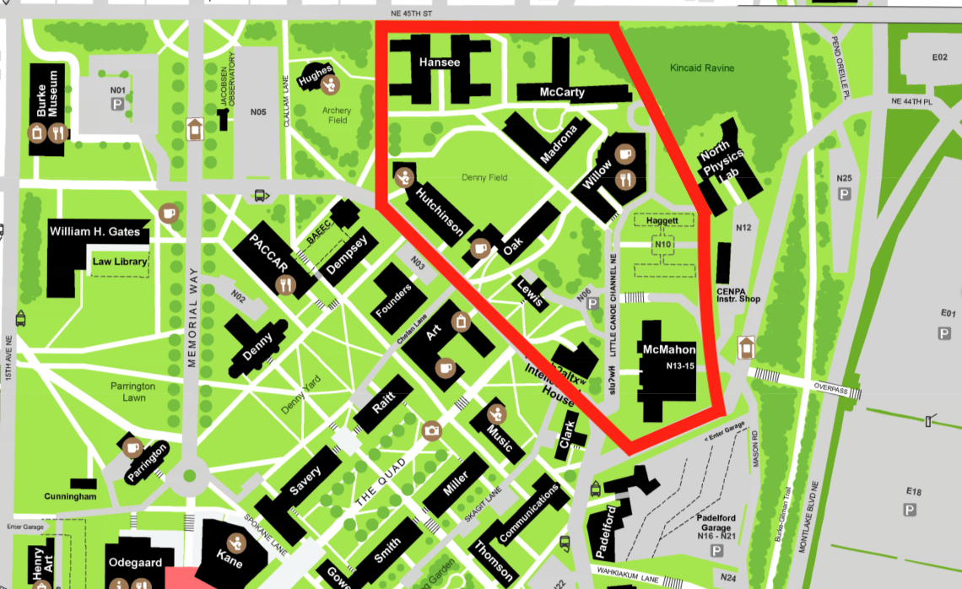 | 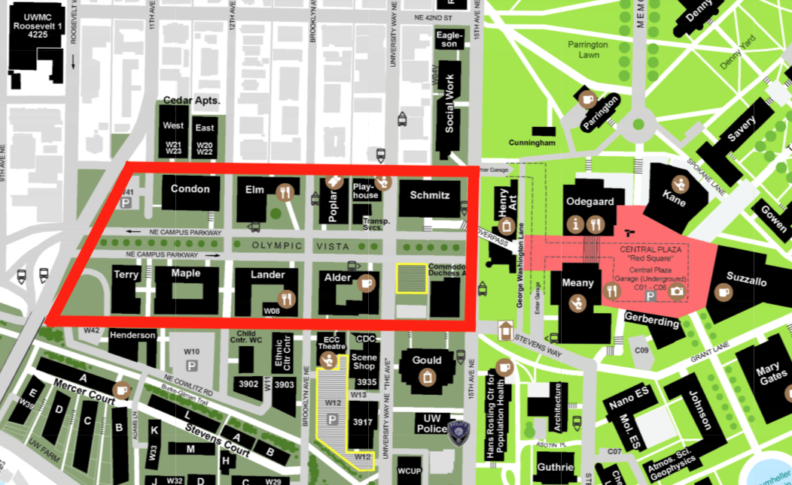
*Based on campus response data from Seattle Fire Department, 9/21/22 - 12/9/22. Calls were only counted if they were in the red perimeter and between 15:00 - 2:00 Friday to Saturday, 15:00 - 2:00 Saturday to Sunday, and 15:00 - 22:00 on Sunday.

Scheduling
Stage 3 requires 4 crews (A-D) of 4 EMTs. For this scheduling system to work, a minimum of 16 EMTs are needed, each working 8h/week. 24 EMTs would allow for greater scheduling flexibility.

Time |  | Friday | Saturday | Sunday
0:00 | 12:00 AM |  | C | B
1:00 | 1:00 AM |  | C | B
2:00 | 2:00 AM |  | C | B
3:00 | 3:00 AM
4:00 | 4:00 AM
5:00 | 5:00 AM
6:00 | 6:00 AM
7:00 | 7:00 AM
8:00 | 8:00 AM
9:00 | 9:00 AM
10:00 | 10:00 AM
11:00 | 11:00 AM
12:00 | 12:00 PM
13:00 | 1:00 PM
14:00 | 2:00 PM
15:00 | 3:00 PM | A | D | C
16:00 | 4:00 PM | A | D | C
17:00 | 5:00 PM | A | D | C
18:00 | 6:00 PM | A | D | C
19:00 | 7:00 PM | B | A | D
20:00 | 8:00 PM | B | A | D
21:00 | 9:00 PM | B | A | D
22:00 | 10:00 PM | B | A | D
23:00 | 11:00 PM | C | B

Student Interest & Personnel Requirements

Student Interest
As with any volunteer-based organization, ensuring UWEMS can provide a reliable and sustainable workforce of volunteer EMTs will be integral to the success of the agency. While interest in a collegiate EMS organization is exceptionally high amongst students, it will take time to translate interest into engagement.

To gauge student interest, a message was sent to 9 listservs and student groups. Within 48 hours, over 100 interested students joined the UWEMS discord.

UWEMS Interested Student Breakdown*
ARC Instructors | Current EMTs | EMTs In Training | Future EMTs
9 | 34 | 9 | 140
Seniors | Juniors | Sophomores | Freshman
65 | 62 | 51 | 8
*Data based on student response data. Updated 12/1/23.

Personnel Requirements
The following table was created based on Pilot Program personnel needs, student response data, and similarly sized universities with on-campus EMS agencies.

UWEMS EMT Requirements and Projections by Stage*
Number of EMTs | Stage 1
Minimum | 4 (Instructors)
Ideal | 8 (Instructors)
Anticipated | 9 (Instructors)
Number of EMTs | Stage 2 | Stage 3
Minimum | 16 | 16
Ideal | 24 | 24
Anticipated | 30 | 40
* Updated 03/12/24. “Minimum” refers to the number of EMTs required for UWEMS to function. “Ideal” refers to the number of EMTs required for optimal scheduling flexibility. “Anticipated” refers to the number of EMTs who would be available to join the organization.

Onboarding and Training

Ongoing Training and Evaluation Program (OTEP)
In order to maintain Washington State credentials, EMTs must complete the ongoing training and evaluation program (OTEP). This training for recertification will be handled by the Head of Training, Megan Bloomingdale. Ms. Bloomingdale is a Senior EMS Instructor in King County and the EMT Program Coordinator at North Seattle College (NSC). As the Head of Training, she oversees all leadership members involved with provider recertification and aids the BOD in all training matters.

Mandated continuing education requirements will include online modules, as well as monthly practical skills testing that will be facilitated by volunteer instructors under Ms. Bloomingdale. She will also lead optional practice training days, with training/testing supplies and rooms being supplied for borrowed use by NSC.

Mental Health Training
The following courses have been identified as required training components for UWEMS EMTs, in addition to the requirements to hold an EMT-B license. Mental health first aid courses have been proven to improve literacy, outcomes, reporting, confidence, and stigma for acute mental health or substance use crises (MHFA Research Summary), which are particularly prevalent on college campuses (SAMHSA College Behavioral Health Report). All of the following courses provide certifications upon completion.

MENTAL HEALTH FIRST AID
Mental Health First Aid is an 8-hour virtual training developed by the National Council for Mental Wellbeing and is offered by Compass Health, northwest Washington’s behavioral healthcare leader. The course gives participants the knowledge and skills to recognize, understand, and respond to indicators of mental illness and substance use disorders.

CREATING SAFE SPACES
Creating Safe Spaces is a 1.5-hour virtual training for first responders developed by the Substance Abuse and Mental Health Services Administration (SAMHSA). The course helps first responders implement personal safety strategies, understand the components of a behavioral health crisis, and take steps to make a safe connection with patients experiencing a mental health and/or substance use crisis.

TRAUMA INFORMED APPROACH
Trauma Informed Approach is a 4-hour virtual training for first responders and law enforcement developed by the Washington State Department of Social and Health Services (WA DSHS). This course gives providers a holistic understanding of trauma, its signs, and its effects on people to best equip them with the tools to provide trauma informed care.

Field Training and Preparation
To ensure that UWEMS EMTs are prepared to handle emergencies on UW campus, they will undergo additional training for campus-specific response.

Bicycle Response Training
All EMTs will undergo bicycle response training to ensure consistency and efficiency among UWEMS members. Training objectives will include, but are not limited to:
- Appropriate fitting of bicycles
  - Bicycle reflectors, bicycle headlights, bicycle tail lights, UWEMS decals, bicycle bags
- Appropriate attire
  - High visibility/reflective vests, UWEMS uniform
- Appropriate stocking of bicycle bags and equipment checklist
  - Top Bag (front pockets): gloves, germicidal wipes, pens
  - Top Bag (main compartment): penlight, trauma shears, convenience bag, nasal cannula (adult, pediatric, infant), non-rebreather (adult, pediatric, infant), oral airways, nasal airways, oxygen tubing, nasal airway lubricant, oxygen tank, oxygen tank key
  - Top Bag (side compartments): BP cuff (adult large, adult, pediatric), stethoscope (adult, pediatric)
  - Left Bag: C-collar (adult, pediatric), bag-valve-mask (adult, pediatric), sterile OB kit, sterile water, tourniquet, multi-trauma dressing, Emergency Response Guidebook, shoe covers, hand sanitizer
  - Right Bag (one): PPE, biohazard bags, sam splint, eye wash saline, paper cups, emergency blankets
  - Right Bag (two): tape, abdominal pad (8”x10”), combine pad (5”x9”), gauze (4”x4”, 3”x3”)
  - Right Bag (three): cold packs, hot packs
  - Right Bag (four): triangular bandages, antibiotic ointment, antiseptic wipes, band aids, nose bleed pinchers, tweezers
  - Right Bag (five): triage tags, chest seals, bulb syringe, burn sheets
  - Right Bag (six): ACE bandages, cling rolls
  - Right Bag (clipboard): transfer of care forms, refusal forms, contact cards, UW resource cards
- Appropriate stocking of jump bag backpack
  - Backpack bag (main compartment): pocket mask, oral glucose, activated charcoal, aspirin, naloxone, epinephrine, portable suction, AED, AED pads (adult, pediatric)
  - Backpack bag (side compartment): pulse oximeter, nail polish remover pads, thermometer
- Pre-shift bike checklist
  - Check that front and rear wheels spin freely without brake pads rubbing against bike frame
  - Check tire pressure
  - Check that brake pads in front and rear brakes stop tires completely
  - Check that bike chain is positioned correctly
  - Check that gears shift properly
- Storage of bikes
  - Bikes are stored indoors, front wheel is locked to the frame
- Safety operations
  - Follow Seattle Department of Transportation Rules of the Road
    - Section 11.44.040: ride near to the ride side of the right lane as is safe, except as may be appropriate when preparing to make or while making turning movements, or while overtaking and passing another bicycle or vehicle proceeding in the same direction
    - Section 11.44.060: do not ride more than two abreast on the roadway or sidewalk, except on paths or parts of roadways set aside for the exclusive use of bicycles
    - Section 11.44.140: use the appropriate hand signals continuously during the last 100 feet traveled by the bicycle, unless both hands are needed to control or operate the bicycle
LEFT TURN: left hand and arm extended horizontally beyond the side of the bicycle.
RIGHT TURN: left hand and arm extended upward beyond the side of the bicycle, or right hand and arm extended horizontally to the right side of the bicycle.
STOP or DECREASE SPEED: left hand and arm extended downward beyond the side of the bicycle
    - Section 11.44.240: the rider of a bicycle will not attach themselves or the bike to any vehicle
    - Section 11.44.260: do not carry any package, bundle or article which prevents the rider from keeping at least one hand of the handlebars, nor will the bike be operated without keeping at least one hand upon the handlebars
    - Section 11.44.160: all bikes are equipped with a lamp on the front which emits a white light visible from a distance of at least 500 feet from the front, and with a red reflector on the seat which shall be visible from up to 600 feet from the rear
    - Section 11.44.200: all bikes shall be equipped with a brake which will enable the operator to make the braked wheels skid on dry, level, clean pavement
    - Section 11.44.210: the rider of a bike must always be attached to the seat
    - Section 11.44.220: no bicycle will carry more persons at a time than the number for which it is designed and equipped
    - Section 11.44.100: bicycles shall have all the rights and duties applicable to a pedestrian’s right-of-way in a crosswalk, but shall yield to pedestrians upon and along a crosswalk
    - Section 11.44.120: bicycles will be operated in a careful and prudent manner and rate of speed no greater than is reasonable and proper under the conditions existing at the point of operation. Every person operating a bicycle upon a sidewalk or public path shall yield the right-of-way to any pedestrians, and shall give an audible signal before overtaking and passing any pedestrian
- Preventative maintenance
  - Ride safely and avoid rough terrain when possible
  - Use a microfiber towel and cleaning products to clean seats, handlebars, brakes and the main beams
  - Note when brakes, chain, or gears begin to appear dirty

Probationary Period
New UWEMS EMT recruits will be identified as “probationary EMTs”, or “EMT observers”. During this probationary period, new members must demonstrate they are able to complete all basic skills in accordance with UWEMS standards. Probationary EMTs will only be scheduled on shifts where there is also a standing EMT member for the duration of their shift. In order to become a standing member of UWEMS, probationary EMTs will be provided a training manual containing a list of objectives that must be observed and signed off by a Field Training Officer, UWEMS Officer or UWEMS Director.

Elements of the training manual include:
- Evidence of completion of standard E-Learning Requirements
  - Sexual Harassment, HIPAA for Covered Entities, Blood Borne Pathogens, IT Security Training, Fire Safety Training, Workplace Harassment
- Evidence of completion of Required Additional Training (detailed above)
- Evidence of attending UWEMS Orientation
- 10 consecutive reported shifts
- Evidence of completion of Campus Map Quiz
- Proficiency in Equipment Check-Off and Restock
- Proficiency in delivery supplemental oxygen
- Proficiency in obtaining vital signs
  - Glasgow Coma Score (GCS), heart rate, SpO2, blood pressure, respiratory sounds, pupils, blood glucose
- Proficiency in bleeding control
- Proficiency in opioid overdose recognition and Narcan administration
- Proficiency in C-spine immobilization and backboarding
- Proficiency in extremity immobilization and splinting
- 4 successfully completed Patient Care Reports (PCRs)
- Evidence of completion in reviewing Medical Protocols
- Proficiency in radio communication
- Proficiency in providing CPR with an AED

Once a probationary EMT has completed their training manual, a final review will be conducted by the UWEMS Logistics Director. If the probationary EMT is deemed to have successfully and appropriately completed all objectives, then they will be moved out of their probationary status, and into a standing member of UWEMS.

Infractions and Disciplinary Actions
Infractions to UWEMS organizational standards and responsibilities will be divided into 2 categories: minor major and major infractions. The nature and extent of disciplinary action will depend on the severity of the infraction and the current status of the EMT (probationary, standing, director).

If an EMT witnesses an infraction, they are required to report it to the Director of Operations. All infractions will be documented and reviewed by the BOD. If an EMT has been part of UWEMS for multiple years, infractions from the previous academic year will not count against their standing for the current year.

MINOR INFRACTIONS  Behavior not aligned with organizational standards or operating procedures of UWEMS | MAJOR INFRACTIONS  Behavior not aligned with overall mission, values and goals of UWEMS
- Showing up >10 minutes late to a scheduled shift without prior notification  - Showing up >10 minutes late to a scheduled UWEMS event without prior notification (UWEMS stand-by events or community outreach events)  - Not showing up to a scheduled shift without finding a replacement or without at least 48 hours of prior notification  - Not showing up to a scheduled UWEMS event without finding a replacement or without at least 48 hours of prior notification (UWEMS stand-by events or community outreach events)  - Failure to maintain at least a 3.0 GPA with good academic standing  - Failure to appropriately check out equipment from Equipment Officer at the start of each shift  - Failure to return equipment at the end of each shift  - Failure to restock used equipment bag at the end of each shift  - Failure to complete mandated OTEP training on time  - Failure to attend regular UWEMS meetings  - Failure to report a witnessed minor infraction  - Unprofessional behavior (not treating other team members with respect, not respecting authority, not being on-time, not taking care of equipment, not dressing in UWEMS uniform at events) | - Not showing up to a scheduled shift without finding a replacement or without at least 24 hours of prior notification  - Not showing up to a scheduled UWEMS event without finding a replacement or without at least 24 hours of prior notification (UWEMS stand-by events or community outreach events)  - Receiving disciplinary action from university (suspension, expulsion etc.)  - Attending a shift or UWEMS-related activity under the influence, or having ingested drugs or alcohol within 24 hours beforehand  - Failure to maintain EMT certification  - Failure to follow HIPAA guidelines and protect patient privacy  - Failure to follow traffic rules and regulations that puts the EMT or the public at risk of harm  - Use of the UWEMS name, image, or likeness inappropriately in public, or improperly in activities not sanctioned or endorsed by UWEMS  - Abuse of power, status or authority  - Failure to report a witnessed major infraction  - Conduct unbefitting of an EMT (gross negligence in patient care, actions that place the community in harm or risk, actions that misrepresent the values of UWEMS)
PROBATIONARY EMT
- 1 minor infraction
  - A warning will be given to the EMT by the Field Training Officer about the nature of the infraction. No further action will be taken.
- 2 minor infractions
  - A second warning will be given to the EMT by the Field Training Officer about the nature of the infraction. No further action will be taken.
- 3 minor infractions
  - A third warning will be given to the EMT by the Field Training Officer about the nature of the infraction. A one-on-one meeting will be scheduled between the EMT and the Operations Director reviewing the previous infractions, and if further actions need to be taken to better support the EMT so that future infractions do not occur.
- 4 minor infractions
  - A fourth warning will be given to the EMT by the Field Training Officer about the nature of the infraction. An additional warning will be given that any more infractions will result in the EMT potentially being removed from UWEMS.
  - 4 infractions during the probationary period will be reviewed by the BOD, and will be noted on the EMT’s training manual. Having 4 infractions may result in the need for an extended probationary period, or not being able to become a standing member in UWEMS.
- 5 minor infractions
  - The Operations Director will inform the probationary EMT that they have had 5 minor infractions, and that their standing within UWEMS will be reviewed by the BOD. The BOD will review the all prior infractions and come to a decision on whether the EMT will be removed from UWEMS, or if they will extend the probationary period.

- 1 major infraction
  - The Operations Director will inform the probationary EMT that they have had a major infraction, and that their standing within UWEMS will be reviewed by the BOD. The BOD will review the infractionand come to a decision on whether the EMT will be removed from UWEMS, or if they will extend the probationary period.

STANDING EMT
- 1 minor infraction
  - A warning will be given to the EMT by a Board member about the nature of the infraction. No further action will be taken.
- 2 minor infractions
  - A second warning will be given to the EMT by a Board member about the nature of the infraction. No further action will be taken.
- 3 minor infractions
  - A third warning will be given to the EMT by a Board member about the nature of the infraction. A one-on-one meeting will be scheduled between the EMT and the Operations Director reviewing the previous infractions, and if further actions need to be taken to better support the EMT so that future infractions do not occur.
- 4 minor infractions
  - A fourth warning will be given to the EMT by a Board member about the nature of the infraction. An additional warning will be given that any more infractions will result in the EMT potentially being placed on probation.
- 5 minor infractions
  - The Operations Director will inform the probationary EMT that they have had 5 minor infractions, and that their standing within UWEMS will be reviewed by the BOD. The BOD will review the infractions and come to a decision on whether the EMT will be placed on probation.
    - If an EMT is placed on probation by decision from the BOD, they will be identified as a “probationary EMT”. In addition, the EMT will forfeit their roles in any existing UWEMS commitments including responsibilities as an Officer, or participation in stand-by events or community outreach events.

- 1 major infraction
  - The Operations Director will inform the EMT that they have had a major infraction, and that their standing within UWEMS will be reviewed by the BOD. The BOD will review the infraction and come to a decision on whether the EMT will be removed from UWEMS, or if they will be placed on probation.
    - If an EMT is placed on probation by decision from the BOD, they will be identified as a “probationary EMT”. In addition, the EMT will forfeit their roles in any existing UWEMS commitments including responsibilities as an Officer, or participation in stand-by events or community outreach events.

DIRECTOR
- 1 minor infraction
  - The infraction will be reviewed by the remaining BOD. A warning will be given by the Chief of UWEMS. If the offending EMT is the Chief of UWEMS, then the warning will be given by the Deputy Chief.
- 2 minor infractions
  - The second infraction will be reviewed by the remaining BOD. A warning will be given by the Chief of UWEMS. If the offending EMT is the Chief of UWEMS, then the warning will be given by the Deputy Chief.
- 3 minor infractions
  - All past infractions (including ones that occurred before the current year) will be reviewed by the remaining BOD. A decision will be made whether the EMT will be removed from UWEMS, or if they will be placed on probation.
    - If an EMT is placed on probation by decision from the BOD, they will be identified as a “probationary EMT”. In addition, the EMT will forfeit their Director role and any other UWEMS commitments. A replacement Director will be found by the BOD.
    - If the EMT who is placed on probation, or removed from UWEMS, is the Chief, then the Deputy Chief will become the “acting Chief '' until a replacement can be found.

- 1 major infraction
  - The BOD will inform the EMT that they have had a major infraction, and that their standing within UWEMS will be reviewed by the remaining BOD. The remaining BOD will review the infraction and come to a decision on whether the EMT will be removed from UWEMS, or if they will be placed on probation.
    - If an EMT is placed on probation by decision from the BOD, they will be identified as a “probationary EMT”. In addition, the EMT will forfeit their Director role and any other UWEMS commitments. A replacement Director will be found by the BOD.
    - If the EMT who is placed on probation, or removed from UWEMS, is the Chief, then the Deputy Chief will become the “acting Chief '' until a replacement can be found.

Dispatch & Documentation

Efficient dispatch and documentation systems are paramount to the success of UWEMS. The following dispatch and documentation solutions have been suggested by Dr. Michael Sayre, the Medical Director of the Seattle Fire Department and Dr. Tom Rea, the Medical Director for King County EMS and have been endorsed by the Seattle Fire Department.

PulsePoint Professional Respond Dispatch
PulsePoint is a mobile app that launched in all of King County in June 2022 under the direction of the Seattle Fire Department and the Medic One Foundation. PulsePoint is fully integrated into 9-1-1 infrastructure, meaning all Seattle 9-1-1 call data flows directly into PulsePoint in real time.
As a registered PulsePoint Agency, the Seattle Fire Department can assign users “Professional Responder” status. For these responders, the PulsePoint app serves as a comprehensive dispatch system, displaying incident details, instant navigation, narrative, and destination view for all 9-1-1 events in real time. UWEMS accounts can be easily configured by the Seattle Fire Department to only receive filtered dispatch notifications for medical emergencies that occur within campus boundaries.
In essence, using PulsePoint allows UWEMS to receive instant dispatch notifications without changing the UW community’s expectation for calling for medical attention, needing to train 9-1-1 operators or SFD staff on dispatch changes, or introducing new steps anywhere in the emergency response system.
The UWEMS training and onboarding program will include covering PulsePoint’s interface, features, and operational procedures, ensuring that EMTs are well-prepared to respond effectively to dispatch notifications.
PulsePoint Dispatch
Time (min.sec) | Entity | Description
0.00 | Patient/Bystander | Dials 9-1-1 and speaks to operator
0.20 | Dispatch Center | Operator enters location, type of emergency, etc
0.20 | UWEMS | PulsePoint dispatch notification received
<1.00 | UWPD | UWPD unit receives assignment and dispatch
<1.00 | SFD | SFD unit receives assignment and dispatch

ESO Software
Robust documentation, analysis, and scheduling software form the foundation of any successful EMS agency. Following the example set by the Seattle Fire Department, UWEMS should adopt the ESO software suite. There are four ESO products, outlined below, that have been deemed essential for UWEMS operations.
Electronic Health Record
ESO EHR, an advanced electronic Patient Care Report (ePCR) system, simplifies quality EMS clinical documentation for EMTs. It covers patient information, vitals, flowcharts, assessments, narratives, and more. Compliant with the National Emergency Medical Services Information System (NEMSIS), EHR automatically submits reports to the Washington State Department of Health.

EHR also facilitates HIPAA-compliant, bidirectional sharing of patient data among EMS agencies. For UWEMS, this means that all documentation done by EMTs flows directly to the Seattle Fire Department in real time. Firefighters can view all information collected by UWEMS and can initiate care exactly where UWEMS left off, eliminating the possibility of redundant data entry and enhancing the patient handoff.

Analytics
ESO Analytics will ensure UWEMS oversight and quality improvement is data-driven. The Analytics software assesses EMS metrics derived directly from EHR. It will enable quick identification of agency trends, visualization of complex data, and generation of weekly reports to track key performance indicators. Additionally, Analytics will be used to create a report to summarize the entire UWEMS Pilot Program, to be used by the Evaluation Committee when making a renewal decision.

Activities
ESO Activities enables scheduling, management, and tracking of non-response initiatives. This system quantifies UWEMS's presence and impact on the UW community, especially in standby and community outreach efforts. It generates daily task lists for on-shift EMTs, ensuring operational success, and doubles as a continuing medical education (CME) training calendar.

Scheduling & Personnel Management
ESO Scheduling & Personnel Management automates flexible scheduling operations for UWEMS. Online timekeeping, shift swaps, schedule calendars, and time-off requests are easily managed. The built-in messaging platform facilitates agency communication, while the credential database ensures EMTs remain up-to-date in their education.

Legal, Liability & Insurance
In the realm of collegiate EMS, the importance of liability management and protection cannot be overstated. Substantial efforts must be made in order to provide an appropriate level of indemnity to volunteer EMTs, the Medical Director, and the University of Washington, including its UWEMS stakeholders. This section outlines an outlined approach to legal structure, liability mitigation and insurance, guided by insights gathered from interviewing successful collegiate EMS agencies and regional stakeholders.

EMT Licensure
WA EMT Licensure Requirements include the following according to the Washington State Department of Health (WA DOH):

- Completion of an accredited EMT course
- Passing score on the National Registry of EMTs exam
- Affiliation with a EMS agency licensed by the WA DOH

The North Seattle College EMT course will be recommended for students. The class aligns with UW’s quarter system, is accessible by light rail, and can be taken alongside a full course load. Passing the NREMT will be an independent responsibility of students, but UWEMS will provide study support. Affiliation with UWEMS will meet the third criteria for the EMT license.
Please refer to Scope of Practice | Level of Care, for information about what work EMTs are authorized to conduct in the State of Washington.

Agency Licensure
UW PMT shall submit an updated agency application to the WA DOH including UWEMS as a state-certified QRS provider under the UW PMT’s ESSO license. This will be facilitated with guidance from Jason Norris and Catie Holstein from the WA DOH, and Randi Riesenberg of the Central Region EMS and Trauma Care Council. Once approved, EMTs gain agency affiliation for their WA state certifications and UWEMS gains access to King County online EMS training resources.

WA EMS Agency Licensure Requirements include the following according to the WA DOH:

- Evidence of Medical and Operational Supervision
- A Dispatch Plan
- A Response Plan
- A Tiered Response and Rendezvous Plan
- Back-up Plan to Respond
- A Response Area Map
- Evidence of Liability Insurance for Vehicles

Medical and operational supervision will fall within the scope of the UWEMS Medical Director and UWEMS Executive Director. Dispatch and response plans are outlined in Dispatch & Documentation. UWEMS will fall within the tiered BLS/ALS response system of King County as a co-responding BLS unit. Response area maps are provided in Stage 3 under Pilot Program Overview and Full Operations under Beyond the Pilot Program. Information on vehicle liability insurance can be found in Volunteer Firemen’s Insurance Services under Legal, Liability, and Insurance.

Once WA state affiliation is established, UWEMS will continue to work with Ms. Riesenberg to become members of the Central Region EMS & Trauma Care Council.

Medical Liability
Historically, the largest risk concerns in collegiate EMS are centered around medical liability. Generously, under RCW 4.24.300, Washington State extends immunity from liability to volunteer EMS providers. Except in cases of gross negligence or willful misconduct, UWEMS is protected from civil damages resulting from any act or omission of rendering care. This immunity does not extend to paid providers, so UWEMS must retain its status as a volunteer organization to maintain this protection. These protections are identical to those afforded to bystanders of a medical emergency under the Good Samaritan Law.
Additionally relevant protections are offered by RCW 24.60.070 and RCW 18.71.210.

UWEMS will follow standard EMS practices that serve to mitigate medical liability, such as using against medical advice (AMA) forms, conducting daily equipment checks, and practicing scene safety precautions. Further, the UWEMS Medical Director will lay out thorough operational protocols that prioritize patient care and mitigating possibilities of medical liability.

UW Compliance and Risk Services
While the Revised Code of Washington grants immunity from medical liability, supplementary insurance is still crucial. Typically, collegiate EMS agencies are either rolled into existing university insurance plans or use funding to purchase insurance through the Volunteer Firemen’s Insurance Services (VFIS).

UWEMS will consult with Risk Services to assess whether it is possible to partially or completely include the agency within existing insurance plans. The proposed budget includes a $7,000 annual insurance charge for complete coverage of liability risks associated with operational risks, management-related risks, work-related injuries or incidents, and equipment loss or theft. This budget has been created assuming non-inclusion of UWEMS liability insurance in university plans. Should integration be viable, this expense will be deducted.

Regardless of the outcome, UWEMS and Risk Services must work together to determine the level of risk that key stakeholders, such as the medical director, will be willing to assume for their services. UW Compliance, more specifically, the Healthcare Privacy Compliance division, will be instrumental in mitigating any risk of PHI breaches and protecting patient information.
UWEMS seeks to establish a close working relationship with UW Compliance and Risk Services so as to establish thorough documentation and operating procedures that sufficiently protect UWEMS staff and patients involved in workplace accidents or injuries.

Finally, UWEMS shall consult Risk Services to ensure that sufficient proof of insurance and general protection exists to protect the UW administrative body and EMTs.

Volunteer Firemen’s Insurance Services
One of the largest insurance providers for volunteer EMS agencies and Fire Departments is the Volunteer Firemen's Insurance Service Inc. (VFIS). VFIS’s insurance products include Property + Casualty and Accident + Sickness coverage, both of which are outlined below. As part of maintaining insurance with VFIS, UWEMS records must be maintained and provided in an annual questionnaire regarding call volume, the number of active volunteers, the number of transports, and UWEMS activities such as public fundraisers or other events.

Property + Casualty Insurance
Broadly, P+C insurance is meant to serve EMS agencies to protect the property and members of their respective organizations. Below, we describe a variety of options applicable to UWEMS.

Relevant P+C Insurance Options Provided by VFIS
Coverages | Description
Property | Protects facilities, grounds, equipment, furniture and personal items
Automobile | Covers damage to vehicles and financial protections for liability risks related to auto-related incidents
General Liability | Financially protects the organization from general operational risks
Management Liability | Financially protects the organization from management-related risks

Accident + Sickness Insurance
A+S insurance serves to help mitigate financial impacts of potential work-related accidents, injuries, or sickness for EMS agencies. Predominantly, A+S insurance will provide funds for members who are injured in the line-of-duty, and also includes illness impairment. As part of its services, VFIS also provides free access to mental health professionals who are experienced in EMS personnel counseling.

Budget Proposal

Timeline
UWEMS Pilot Program
Stage 1 |  | Stage 2 | Stage 3
3 Months | 3 Months | 3 Months | 3 Months
$3,582.03 |  | $42,032.54 | $25,843.85

UWEMS Total Pilot Cost
3 Months | 3 Months | 3 Months | 3 Months
$71,458.42
UWEMS Fully Operational Year 2+
3 Months | 3 Months | 3 Months | 3 Months
$69,402.58

Itemized Budget
UWEMS Pilot Program Budget Sheet Draft
Above is a link to an itemized breakdown for the estimated costs of UWEMS. Listed items are in compliance with WAC 246-976-300 and have been cross-referenced with existing collegiate EMS agencies, to ensure all required components have been included in the budget.

It is important to acknowledge that actual costs will be less than those outlined in the budget. Internal discounts, donations of equipment, and bulk ordering options for purchases have not been accounted for.
Additionally, annual maintenance costs are expected to be lower than in the Pilot Program or during the first year of operation, due to the reduced need to repurchase new equipment annually. If it is decided that the UWEMS Pilot Program should not be renewed, all equipment will be sold and the money will be redistributed to the appropriate funding sources. Items that cannot be sold will be donated to the Paramedic Training Program.

Quality Assurance and Quality Improvement

Public Training & Community Outreach
American Red Cross CPR & AED Education
At the end of every training course, participants are asked to complete an End-of-Session Survey. In the End-of-Session Survey, questions will be asked regarding knowledge improvement and general impression of students from the course. Assessment will be conducted using data with the following questions:

- On a scale of 1-5, rate your confidence level of being able to provide high quality CPR in an emergency setting before this course
- On a scale of 1-5, rate your confidence level of being able to provide high quality CPR in an emergency setting after this course
- On a scale of 1-5, rate your level of knowledge about how to use an AED before this course
- On a scale of 1-5, rate your level of knowledge about how to use an AED after this course
- On a scale of 1-5, rate how well you feel you have retained the information from this course
- On a scale of 1-5, how helpful was the course to your personal or academic goals
- On a scale of 1-5, how likely would it be that you would pursue CPR certification if it was not offered by UWEMS
- On a scale of 1-5, how likely are you to pursue further training in EMS
- Did you have PulsePoint installed before this training
- Did you install PulsePoint as a result of this training
- Would you recommend this course to someone else

Opioid Overdose Recognition & Naloxone Administration Education
At the end of every training course, participants are asked to complete an End-of-Session Survey. In the End-of-Session Survey, questions will be asked regarding knowledge improvement and general impression of students from the course. Assessment will be conducted using data with the following questions:

- On a scale of 1-5, rate your confidence level of being able to recognize an opioid overdose in an emergency setting before this course
- On a scale of 1-5, rate your confidence level of being able to recognize an opioid overdose in an emergency setting after this course
- On a scale of 1-5, rate your confidence level of being able to properly administer Naloxone Nasal Spray before this course
- On a scale of 1-5, rate your confidence level of being able to properly administer Naloxone Nasal Spray after this course
- On a scale of 1-5, rate your level of knowledge about what to do after administering Naloxone Nasal Spray before this course
- On a scale of 1-5, rate your level of knowledge about what to do after administering Naloxone Nasal Spray after this course
- On a scale of 1-5, rate how well you feel you have retained the information from this course
- On a scale of 1-5, how helpful was the course to your personal or academic goals
- On a scale of 1-5, how likely would it be that you would pursue this training if it was not offered by UWEMS
- On a scale of 1-5, how likely are you to pursue further training in EMS
- Would you recommend this course to someone else
Additional Outreach
The impact of non-training outreach efforts measured by the following
- Number of community events participated in
- Number of people interfacing with UWEMS at community events
- Number of UW students pursuing EMT training at North Seattle College
- Number of students participating in UWEMS as instructors or EMTs
- Level of engagement with UWEMS social media outlets

Call Review
To assure that UWEMS care meets a high standard, every UWEMS call response will be reviewed by a Crew Captain. A Crew Captain is a senior EMT and experienced member of the agency. The Crew Captain will review the call with the responding crew and provide feedback and suggestions for improvement regarding the following:

- Precision, accuracy, and quality of the patient care report documentation
- Precision, accuracy, and quality of clinical decision-making and provided care.

After review with the EMT crew, if a call meets any of the following criteria, it will also be reviewed by the UWEMS Clinical Care Committee.

- Any call in which Advanced Life Support was needed, dispatched, or indicated
- Any call in which a patient was given a medication
- Any call in which there was an unusual patient presentation or medical situation
- Any call in which there was an unusual operational event
- Any call in which there was a high-risk refusal of care
- If the Crew Captain deems committee review beneficial
- If explicitly requested by the responding crew

The Clinical Care Committee, composed of all Crew Captains and chaired by the Director of Logistics, shall meet on a monthly basis. The UWEMS Medical Director and Executive Director will also be invited to these monthly Clinical Care Committee meetings on a nonmandatory basis. Selected calls would be discussed anonymously and particularly notable calls will be flagged. If needed, a follow up will be conducted with the responding crew.
Flagged calls will be compiled and presented to the UWEMS Medical Director and Executive Director on a quarterly basis. The UWEMS Medical Director will be consulted on questions about medical procedure and the Executive Director will be consulted on questions of operational procedure. This quarterly consultation will be open to all of UWEMS, to ensure that EMTs have an opportunity to ask questions and learn from mistakes on calls.

Clinical Data
The success and impact of UWEMS will be measured through a comprehensive evaluation of key performance indicators. These have been gathered from collegiate EMS agencies at peer institutions and the National EMS Quality Alliance (NEMSQA) Process Measures Set.
The UWEMS Director of Logistics will track indicators, including but not limited to:
- Average call-to-response time
- Average scene time
- Number of patient contacts
- Demographics of patients served
- Total hours of medical standby coverage provided to the University of Washington
- Total hours of continuing education provided to UWEMS providers
- Percentage of EMS responses originating from a 911 request for patients with symptomatic hypoglycemia who receive treatment to correct their hypoglycemia
- Percentage of EMS responses originating from a 911 request for patients with primary or secondary impression of respiratory distress who had a respiratory assessment
- Percentage of EMS responses originating from a 911 request for patients with hypoxia during which oxygen is administered
- Percentage of EMS responses originating from a 911 request for patients less than 18 years of age who received a weight-based medication and had a documented weight in kilograms or length based weight estimate documented during the EMS response
- Percentage of EMS responses originating from a 911 request for patients suffering from a suspected stroke who had a stroke assessment performed during the EMS response
- Percentage of EMS transports originating from a 911 request for patients with suspected traumatic brain injury during which oxygen level, ETCO2, and systolic blood pressure are documented
- Percentage of EMS responses originating from a 911 request for patients with injury who were assessed for pain
- Percentage of EMS transports originating from a 911 request for patients whose pain score was lowered during the EMS encounter
- Percentage of EMS transports originating from a 911 request for patients with trauma during which Glasgow Coma Scale (GCS) score, systolic blood pressure, and respiratory rate are documented
- Percentage of EMS responses originating from a 911 request for patients not transported by EMS during which a basic set of vital signs is documented
- Percentage of EMS responses originating from a 911 request in which a ‘last known well’ was documented

Community Feedback
A feedback and comment form will be made available to all members of the University community on the UWEMS website. A UW Net ID will not be required to fill out this form and submissions may be made anonymously. A submission can be made regarding interactions, concerns, or suggestions regarding UWEMS. This form assures that UWEMS is operating at the highest level of professionalism and is being perceived favorably by community members.

The UWEMS Director of Outreach will review this feedback form on a monthly basis, bringing notable comments to the UWEMS BOD. At the discretion of the BOD, notable comments will be taken to the UWEMS Executive Director.

Annual Report
At the end of each academic year, the BOD will release an annual report surrounding the activities of UWEMS. This document shall be made publicly accessible and will be shared with campus, regional, and state stakeholders.
Following the completion of the Pilot Program, an Evaluation Committee should be established and tasked with making an informed recommendation to the UW Administration on providing UWEMS any necessary permissions for providing long-term services. The membership of this committee shall be set at the discretion of the UW Paramedic Training Program.

Beyond the Pilot Program

Full Operations
Contingent on University of Washington Administration approval
Campus-Scale Emergency Response
Time and Area Coverage
In this large-scale emergency response system, UWEMS would respond to emergencies anywhere on campus with limited response time coverage. This fully expanded area coverage allows UWEMS to begin functioning as a fully operational, UW emergency medical response system. As UWEMS operations grow and become better ingrained within the emergency medical response system, the limited response time coverage will be expanded to 24/7 coverage. This evolution will be pursued at a future time with the support and oversight of university and community stakeholders such as UW administration, UW PMT, SFD, and more.

Operations
UWEMS would continue to use bicycles as the primary means of transportation. At this point, in consultation with Facilities, a permanent location must be identified on campus to serve as UWEMS headquarters. The requirements are that the space is 1) Located somewhat centrally on campus, 2) Has room for at least 6 EMTs to sit, sleep, and store medical equipment, and 3) Has storage space for 6-8 bicycles.

UWEMS Projected Campus Total Call Volume by Quarter*
Winter | Spring | Summer | Autumn
119 | 123 | 53 | 174
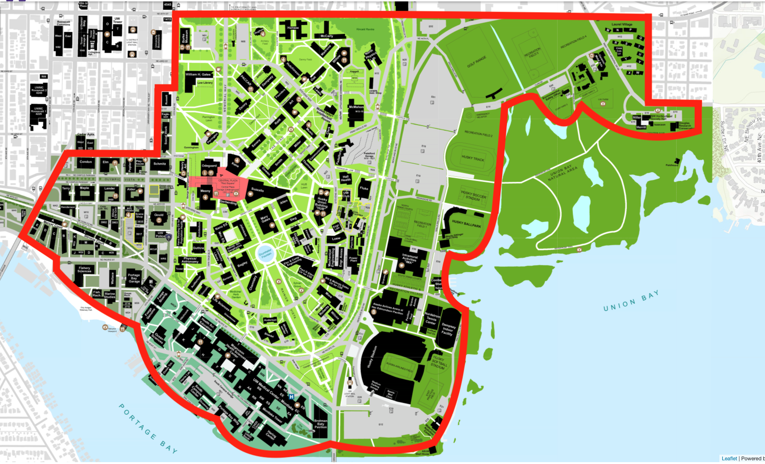
*Based on campus response data from Seattle Fire Department, 6/17/22 - 8/16/22 and 9/20/22 - 6/16/23. All calls within the red perimeter were counted.

Personnel
Reaching a threshold of 24 volunteers for our limited response time model is within reason based on what we’ve seen at other universities, especially those that use volunteer models. The following table (next page) outlines the number of volunteers found at similarly sized schools.

Collegiate EMS Volunteer Counts at Other Universities
University | Volunteers | Enrollment | Campus Size (Acres)
University of Texas at Dallas | 70 | 29,543 | 500
University of Pennsylvania | 70 | 24,806 | 299
Ohio State University | 80 | 66,444 | 1,665
University of Minnesota | 90 | 52,376 | 1,204
University of Arizona | 80* | 44,831 | 392
University of North Carolina | 50 | 29,469 | 729
*Began as a volunteer organization, but has since received funding to pay students

Research
We aim to establish a robust research division focused towards diverse and detailed data collection of calls run involving UWEMS EMTs, as well as statistical analysis so as to identify any areas of improvement in patient care, logistics, or efficiency.

Before allowing any research to occur, however, we fully recognize and understand that research of this nature must be conducted ethically, with informed consent, and that the handling of sensitive protected health information must be conducted properly. Because of this, UWEMS will first need to obtain approval from the Institutional Review Board (IRB) to ensure that all research will be conducted properly and ethically.

UWEMS statistical analysis will be conscientiously shared with the public through papers published in peer-reviewed journals, such as the Journal of Collegiate EMS (JCEMS) or Journal of American College Health (JACH). Collaborations with UW School of Medicine faculty and students in these efforts would be preferred.

Special Thanks & Acknowledgements

The following people all volunteered their time and expertise to help augment this proposal. If not for their willingness to provide guidance, advice, and support, the UWEMS initiative would not be where it is today.

Eric Timm - Director of UW Paramedic Training
Harold D. Scoggins - Chief of the Seattle Fire Department
Dr. Michael Sayre - Medical Director of Seattle Fire Department and UW Professor of Emergency Medicine
Dr. Thomas Rea - Medical Program Director of King County EMS and UW Professor of Medicine
Lt. Kenny Stuart - President of Seattle Firefighters Union, IAFF Local 27
Lt. Tony Savelli - Director of Seattle Firefighters Union, IAFF Local 27
Lt. Ryan Ellis - Director of Seattle Firefighters Union, IAFF Local 27
Capt. Doug Johnson - SFD Station 17
Capt. Chris Dockter - SFD Station 17
Megan Bloomingdale - King County Senior EMS Instructor and NSC EMT Program Coordinator
Cathryn Holstein - Washington State Department of Health EMS Director
Jason Norris - Washington State Department of Health EMS and Trauma Prehospital Liaison
Randi Riesenberg - Executive Director at the Central Region EMS and Trauma Care Council
Mark Taylor - Chair of the Central Region EMS and Trauma Care Council
Sally Clark - UW Vice President for Campus & Community Safety
Glenna Chang - UW Associate Vice President for Student Life
Daron Vchulek - UW Hall Health Associate Director
Natacha Foo Kune - Director of UW Counseling Center
Joel Schwarzkopf - Director of UW Medicine Hall Health Center
Dr. Maureen Koval - Head of UW Medicine Hall Health Urgent Care
Josh Gana - UW HFS Director of Operations
Barry Morgan - Director of UW Emergency Management
Scott Nelson - EH&S Fire Safety Manager
Dr. Joseph Grover - NCEMSF Startup Coordinator
Dr. Scott Savett - NCEMSF Vice President

US Map of Existing Collegiate EMS Agencies
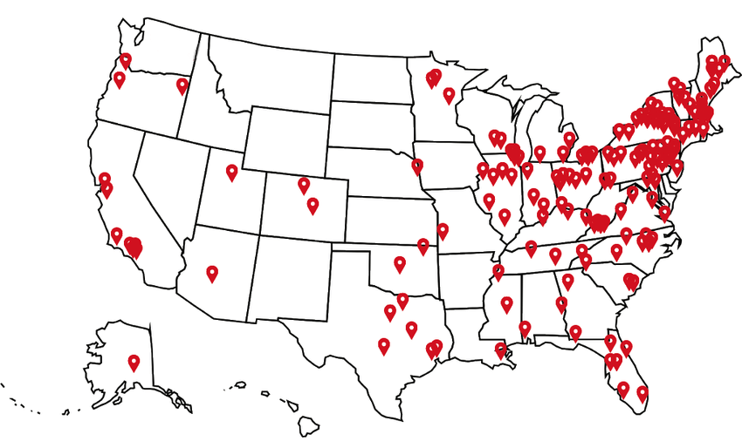

Appendix B – UWEMS Organizational Chart

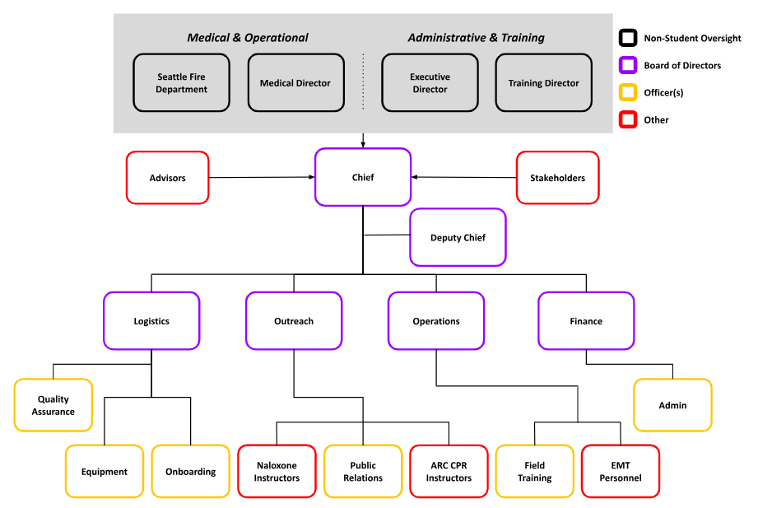

Appendix C - University of Washington Campus Map - UWEMS Response Zone

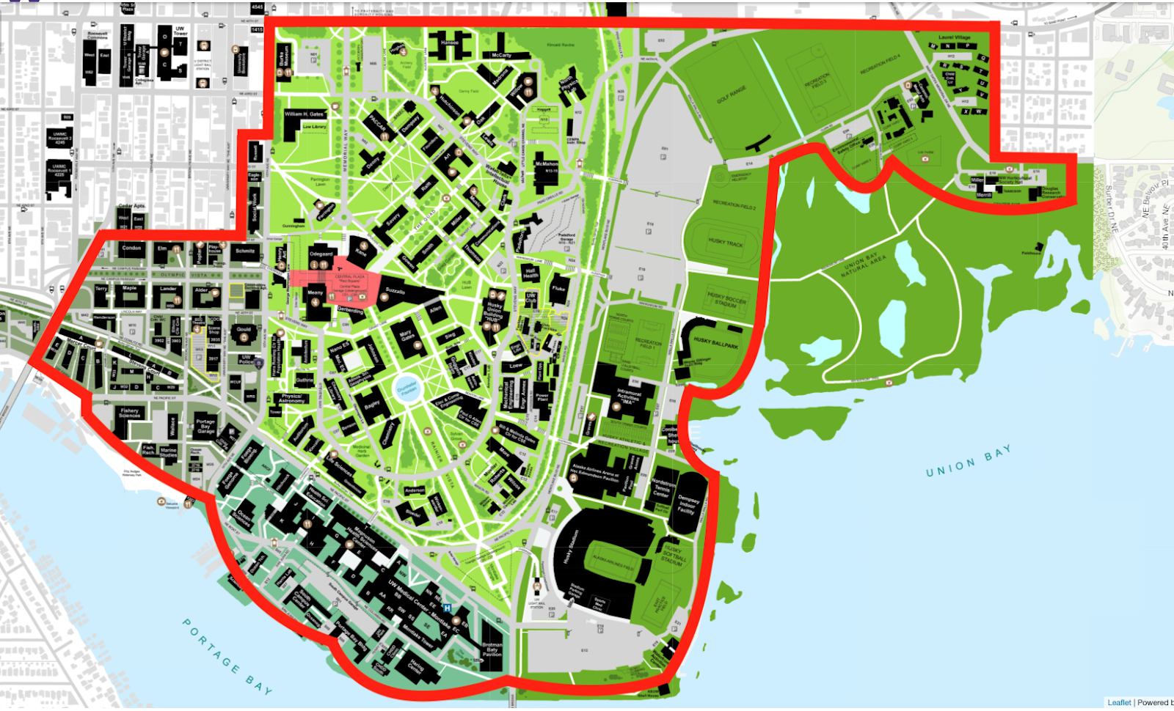

Appendix D - Board Bill 5.05 - Resolution for the Establishment of a Collegiate-Based EMS Program at University of Washington


BOARD OF DIRECTORS
Session 123
Date: February 21st, 2024
Submitted by Andal Sridhar
Senate Vice Speaker
BOARD BILL 5.05: Resolution for the Establishment of a Collegiate-Based EMS Program
at University of Washington
Sponsors: Tristan Jafari, Tanmay Bhanushali
Senate Vote: 51-0-9
WHEREAS, the health, safety, and well-being of students, staff, faculty, and community members at the University of Washington is a priority and of paramount importance;
WHEREAS, emergency medical services (EMS) agencies play a critical role in providing immediate medical attention during acute mental, behavioral, and physical health emergencies;
WHEREAS, the University of Washington is home to a dense population of young adults, creating a need for tailored and effective health services;
WHEREAS, collegiate-based EMS (CBEMS) agencies are state-licensed EMS agencies that are adapted to and solely operate on a college campus and are staffed by students who are Emergency Medical Technicians (EMTs);
WHEREAS, EMTs are state-certified medical professionals who are trained and licensed to provide effective prehospital medical care at the basic life support level [1];
WHEREAS, CBEMS agencies have been successfully established on over 250 different college campuses [2], including large state universities similar to the University of Washington [3,4];
WHEREAS, 41% of college students experience moderate or major depression, 36% experience anxiety disorders, 14% experience suicidal ideation, and 29% engage in non-suicidal self-injury [5];
WHEREAS, 27.4% of college students report engagement in binge drinking [6], and 7% report misuse of prescription opioids [7];
WHEREAS, the high prevalence of behavioral and substance use emergencies poses a threat to the health of students and impedes the mission [8] of the University of Washington;
WHEREAS, barriers to the reporting of the aforementioned sensitive medical emergencies exist, especially if patients or bystanders are apprehensive of potential repercussions or unintended consequences to their actions [9,10];
WHEREAS, student-providers have a shared identity with student-patients, making them more likely to identify with shared stressors;
WHEREAS, a shared patient-provider identity and life-stage leads to improved healthcare delivery, medical trust, care perception, and outcomes [11,12,13];
WHEREAS, students are more than twice as likely to call for medical attention when they know that first responders are peers, particularly in cases of sensitive emergencies, such as drug abuse, alcohol intoxication, and mental health crises, cultivating a community that prioritizes safety over stigma [14];
WHEREAS, CBEMS providers receive further specialized training in mental health first aid, which enhances the ability of responders to assess and treat mental health emergencies;
WHEREAS, faster response times are linked to better healthcare outcomes [15,16], particularly in cases of life-threatening emergencies, such as sudden cardiac arrest [17];
WHEREAS, CBEMS agencies have an average response time of 2.6 minutes [18], allowing for the initiation of medical care delivery 3.78 minutes prior to the arrival of the Seattle Fire Department [19];
WHEREAS, mass gatherings occur frequently at the University of Washington, including but not limited to sporting contests, conferences, Greek life, events, concerts, political demonstrations, religious celebrations, move-in or out, and Dawg Daze;
WHEREAS, mass gatherings exhibit increased health risk profiles due to weather hazards, infectious disease, physical altercations, substance use, more difficult access to medical facilities, and crowd disturbances [20,21];
WHEREAS, stationing standby EMS personnel at mass gatherings is a proactive provision of healthcare to address increased risks by allowing for rapid onsite stabilization, treatment, and intervention [22];
WHEREAS, medical standby services prevent resource strains to local fire departments, EMS agencies, and emergency departments [22];
WHEREAS, CBEMS agencies provide medical standby services at mass gatherings that occur on their respective college campuses [23];
WHEREAS, a CBEMS agency offers invaluable leadership and professional development for students, which are key alongside academic growth to prepare students to make lasting impacts beyond the University of Washington;
WHEREAS, hands-on and experiential learning in medicine is highly sought by current and prospective students who are considering careers in healthcare;
WHEREAS, fostering diversity within a CBEMS agency creates opportunities for underrepresented students who would otherwise not have considered careers as EMTs, firefighters, paramedics, and physicians;
WHEREAS, Washington State Legislature recommends training students in Cardiopulmonary Resuscitation (CPR) in order to foster future generations of capable responders [24];
WHEREAS, University of Washington Environmental Health & Safety recommends community members to pursue CPR/AED training through the American Red Cross [25];
WHEREAS, the Graduate and Professional Student Senate of the University of Washington has previously resolved that trainings for CPR, AED, and naloxone use should be made available to the University community at low or no cost [26];
WHEREAS, CBEMS agencies partner with organizations like the American Red Cross, American Heart Association, and college campus entities to provide CPR, AED, and naloxone use certifications at no cost to university-affiliated persons [27];
WHEREAS, such initiatives equip individuals with life-saving skills, foster a more resilient community, and promote a culture of emergency preparedness at the University of Washington;
WHEREAS, King County has adopted PulsePoint, a location-based mobile app, fully integrated within the 9-1-1 system, that alerts trained community members to cases of sudden cardiac arrest in their vicinity [28];

THEREFORE, BE IT ENACTED BY THE ASSOCIATED STUDENTS OF THE UNIVERSITY OF WASHINGTON BOARD OF DIRECTORS:
THAT, on behalf of the student body, the ASUW recognizes the need for and benefit of a collegiate-based EMS agency at the University of Washington;
THAT, a collegiate-based EMS agency shall be established at the University of Washington that co-responds with the Seattle Fire Department to provide non-transport basic life support services;
THAT, the collegiate-based EMS agency at the University of Washington shall lead community trainings and issue certifications in CPR, AED, and Naloxone use for low or no-cost to the University community;
THAT, the collegiate-based EMS agency at the University of Washington shall offer medical standby services to the community;
THAT, the collegiate-based EMS agency at the University of Washington shall promote community usage of the PulsePoint Respond and PulsePoint AED mobile apps;
THAT, adequate funding shall be allocated by the University of Washington to support the establishment, operation, and sustainability of the collegiate-based EMS agency;
THAT, UW Housing & Food Services and UW Facilities shall provide a space and sleeping quarters on campus that may serve as the main operating home and base for a collegiate-based EMS agency at the University of Washington;
THAT, campus stakeholders such as UW Hall Health, UW Counseling Center, and UW SafeCampus shall act in an advisory capacity to a collegiate-based EMS agency, in order to ensure services are comprehensively addressing campus health and safety;
THAT, UW Emergency Management, UW Police Department, and Environmental Health & Safety shall reflect the operations of a collegiate-based EMS agency in campus emergency preparedness and response plans;
THAT, a comprehensive report on the progress and impact of the collegiate-based EMS agency shall be presented publicly, to ASUW, and to GPSS annually;
THAT, a copy of this resolution be forwarded to:
Ana Mari Cauce, President of the University of Washington
Tricia Serio, Provost of the University of Washington
Eric Timm, Director of Paramedic Training at the University of Washington Michael Sayre, Professor of Emergency Medicine
Tom Rea, Professor of Medicine
Susan Stern, Chair, Department of Emergency Medicine
Sally Clark, Vice President, Campus Community Safety at the University of Washington Denzil Suite, Vice President, Student Life at the University of Washington Glenna Chang, Associate Vice President, Student Life at the University of Washington Natacha Foo Kune, Director, UW Counseling Center
Craig Wilson, Chief of the University of Washington Police Department Cindy Dougherty, Faculty Senate Chair, Professor of Cardiac Nursing
Hillary Godwin, Dean of the School of Public Health, Chair, Board of Deans and Chancellors Lou Cariello, Vice President, UW Facilities
Carrie Moore, Husky Union Building (HUB) Executive Director
Pamela Schreiber, Housing and Food Services (HFS) Executive Director Joel Schwarzkopf, Hall Health Executive Director
Mary Kauffman, Hall Health Medical Director
Daron Vchulek , Hall Health Associate Director
Katia Harb, Senior Director, Environmental Health & Safety
Scott Nelson, Fire Safety & Engineering Manager, Environmental Health & Safety Kelley Biastock, Director of UW Emergency Management
Barry Morgan, Plans, Training & Exercise Manager of UW Emergency Management Gillian Wickwire, Director of UW SafeCampus
Matt Newman, UW Recreation Director
A.J. Balatico, GPSS President
Jacob Feleke, ASUW President
Jay Cunningham, Student Regent
Mitchell Klein, SAF Chair
Lucas Wang, STF Chair
Kyle McDermott, CSF Program Director
End
References:
1. NREMT. https://www.nremt.org/EMT/Certification
2. NCEMSF. https://www.ncemsf.org/
3. UAEMS. https://ems.arizona.edu/
4. UEMR. https://police.utdallas.edu/programs-and-services/uemr/
5. Eisenberg et al., Healthy Minds Network. https://healthymindsnetwork.org/wp content/uploads/2023/08/HMS_National-Report-2022-2023_full.pdf
6. College Drinking Prevention.
https://www.collegedrinkingprevention.gov/statistics/prevalence
7. McCabe et al., Addictive Behaviors.
https://www.sciencedirect.com/science/article/abs/pii/S0306460304003028 8. About The UW. https://www.washington.edu/about/visionvalues/
9. Koester et al., Int J Drug Policy. https://www.ncbi.nlm.nih.gov/pmc/articles/PMC5825210/ 10. Follet et al., Critical Social Work. https://ojs.uwindsor.ca/index.php/csw/article/view/5905
11. Friedman et al., J Am Coll Health.
https://www.tandfonline.com/doi/full/10.1080/07448481.2022.2104616
12. Kamimura et al., J Patient Exp. https://pubmed.ncbi.nlm.nih.gov/33457601/
13. Mental Health America.
https://www.mhanational.org/sites/default/files/Evidence%20for%20Peer%20Support%20Ma y%202019.pdf
14. Rosen et al., J Am Coll Health. https://pubmed.ncbi.nlm.nih.gov/22420705/ 15. Blanchard et al., Prehosp Emerg Care. https://pubmed.ncbi.nlm.nih.gov/22026820/ 16. Bryne et al., JAMA Surg. https://pubmed.ncbi.nlm.nih.gov/30725080/ 17. Holmén et al., https://pubmed.ncbi.nlm.nih.gov/33107394/
18. Fisher et al., Prehosp Disaster Med. https://pubmed.ncbi.nlm.nih.gov/16770998/
19. Seattle Fire Department Annual Report 2022.
https://www.seattle.gov/documents/Departments/Fire/About/2022_Annual_Report_Web.pdf
20. Tavan et al., J Educ Health Promot.
https://www.ncbi.nlm.nih.gov/pmc/articles/PMC6852309/
21. CDC Yellow Book. https://wwwnc.cdc.gov/travel/yellowbook/2024/work-and-other reasons/mass-gatherings
22. Wolin et al., StatPearls. https://pubmed.ncbi.nlm.nih.gov/37983354 23. GEMRU. https://police.ufl.edu/gemru/
24. RCW 28A.230.179. https://app.leg.wa.gov/rcw/default.aspx?cite=28A.230.179
25. EH&S Fire & Life. https://www.ehs.washington.edu/fire-life/automated-external defibrillators
26. GPSS Resolution on Naloxone/AEDs. https://drive.google.com/file/d/1K0Ql 2yK0jsODiFUFZgPjid_psF_3XBy/view?usp=sharing
27. Penn MERT. https://pennmert.org/our-services/
28. Pulsepoint Seattle. https://www.pulsepoint.org/news/kc-fire-chiefs-medic-one-foundation adopt-life-saving-app

Appendix E –Figures in Color

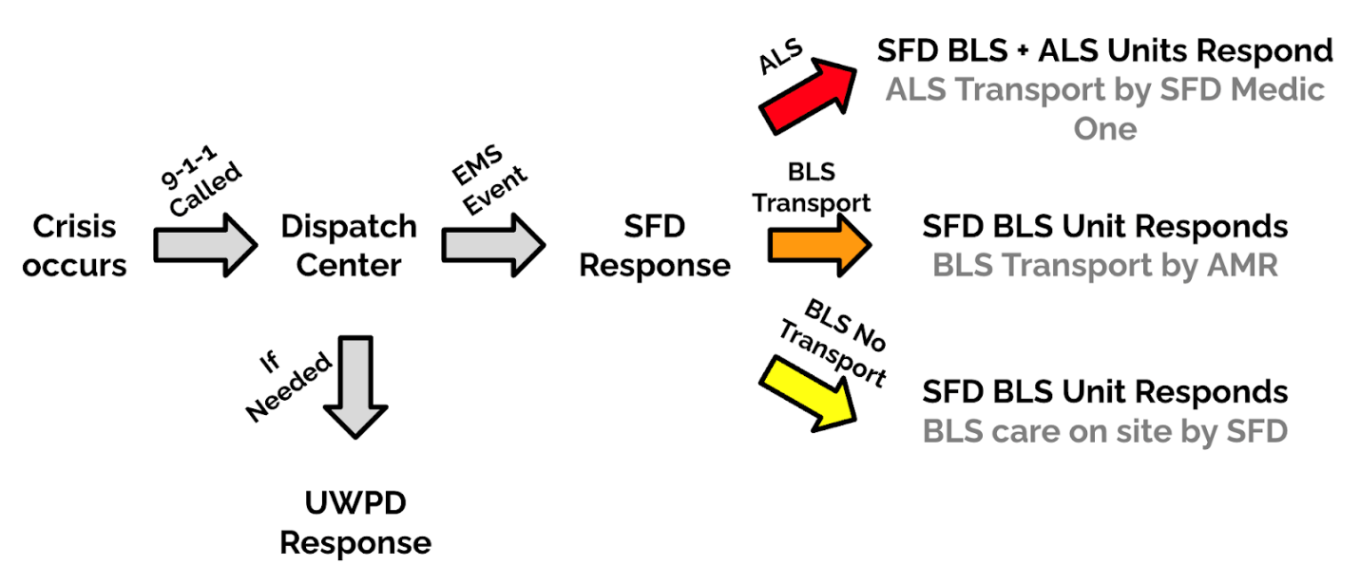
Figure 1. Response Model for On-Campus Emergencies

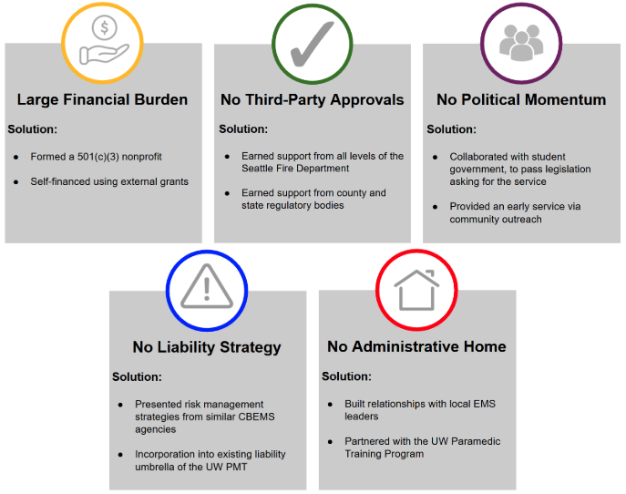
Figure 2. Summary of Barriers

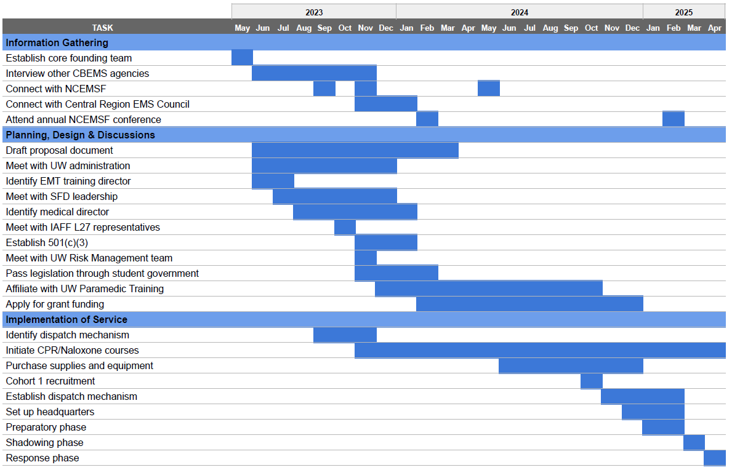
Figure 3. UWEMS 2023-2025 Timeline

Response time defined as turnout time (time span between a unit being assigned to being en route) + arrival time (time span between a unit being en route to on-scene)
CPR Tacoma. https://www.cprtacoma.org/what-is-the-average-cost-of-cpr-certification-classes-in-tacoma
NIH. https://nida.nih.gov/research-topics/trends-statistics/overdose-death-rates
ADAI. https://adai.washington.edu/wadata/opiate_home.htm

